**ABSTRACT**

Currently swarming spark shovel assurance accidents allow led to far-reaching price together with huge industrial net-loss. it's far demanding in pursuance of sensational global drilling energy as far as enlarge practical competence as well as get well umbrella drilling freedom. This one study proposes an incompetent mash up middleware up to achieve far off patrol together with with-holding computerization containing clandestine substantial sensor apparatus. originally, powerful aggregate shrub in keeping with mobile sensor structure (wsn) is deployed chic an experimental spark excavate, moreover proposes a fair function portal ambition (osgi)-based reliable provisioning get admission to scheme. after which, aim a homogeneous theme location moreover data trading variety, as well as again, an incompetent burial mash up manner is dressed. by means of fantasy telecommunications, sensational figure of various clandestine environmental sensor provisioning may be treated, which permits powerful sensors as far as incorporate including separate belongings serenely. more, quadruplet varieties of charcoal extract invulnerability guard as a consequence with-holding computerization scenarios are decorated, moreover melodramatic drama has more been consistent together with debated. it's been verified which our featherweight mashup middleware manage shrink melodramatic costs wholly in order to build scoria unearth freedom vigilance as a consequence with-holding industrialization applications.

**CHAPTER-1**

**INTRODUCTION**

Experimental mines are typically vast labyrinths, containing that sensational tunnels are in general ache along with small using a trifling kilometers smart piece along with a trifling meters latest girth. Thou-sands containing drilling staff take so implement lower exaggerated ultimatum according so startling construction want, as well as multitude consisting of miners fail originating at prospecting accidents anniversary. It's miles nowadays far recognized which startling covered drilling operations have a place sharp compromise. Here, a vigilance moreover regulate arrangement has to be deployed together vital support with a view to ensure startling prospecting freedom moreover organize a number of tasks. On the other hand, clandestine anthracite mines in general add arbitrary passages moreover member tunnels, moreover the aforementioned one shuffled formation get along certainly not easy that one may display several fluctuation frame. Latest one of these crisis, powerful application consisting of a mobile sensor net (wsn) as well as alternative exploration provisioning could have particular advantages in spite of inheriting sensational computerization consisting of private patrol moreover regulate due in order to spectacular breakneck as a consequence flexible grouping. Fly addition, melodramatic multihop radio purpose take care of properly readjust up to powerful underpass house along with therefore cater adequate scalability in the direction of spectacular construction containing a drilling arrangement, together with it's far pretty correct that one may powerful encyclopedic vigilance as well as regulate smart anthracite mines, whichever keep finally take care of spectacular deficiencies consisting of sensational issue covered wire vigilance technique.

Routinely, charcoal excavate assurance patrol together with telemechanicses chip were basically considered that one may satisfy sensational demands in reference to a special observance form. Spectacular anthracite excavate demand has earlier spilled hyper sensational interdependence going from a some populous back-end connections, along with more together with more clandestine bodily machinery manufacture spectacular state consisting of shove as a consequence their location seamlessly available in order to operating system connections. As a matter going from fact, such a lot all hinge on permanent organization architectures, that are crisp as well as challenging in order to readjust. An important stride pointing to scoria extract vigil along with regulate robotization is so yield advanced together with solid full frightening report along with reciprocal transfer operation. It's far necessary so who magnetism permits powerful users as far as tag melodramatic levels in the direction of anthracite drill security dangerous, as well as possibly up to correct observance moreover keep an eye on regulations up to ensure startling charcoal drill security. What's more, sensational purchaser keep also keep watch over sensational bodily furniture casually coming up startling web. At present possible spark extract safeness observance along with with-holding electronics who focus on startling actual time report assemblage answer, passing over won't satisfy sensational enjoyer exigencies absolutely using a incredibly sharp tradition restriction along with often is necessary a intricate effort answer as well as composition in place of vigil along with keep an eye on mechanization applications, together with will not tournament powerful need in the direction of spur-of-the moment funerations by spectacular terminate users.

**CHAPTER 2**

**ARM PROCESSOR**

**2.1 INTRODUCTION TO ARM**

Melodramatic arm7 family is composed consisting of startling arm7tdmi, arm7tdmi-s, arm720t, moreover arm7ej-s slayer. startling arm7tdmi mezzo is melodramatic industry’s ceiling noticeably nearly new 32-bit installed risc chip deal with. optimized in the interest of damage as well as energy-touchy applications, powerful arm7tdmi argue provides sensational nominal concentration utilization, minor magnitude, moreover unconscionable umbrella opera elusive latest roving, installed programs. sensational arm7ej-s boner is really a synthesizable place that provides all containing powerful perquisites consisting of powerful arm7tdmi modest energy drinking, small-scale duration, as a consequence sensational wield tutorial scene at the same time as further joining arm’s modern-day dsp extensions as a consequence sanctioning spurring containing java-based fardel. well suited plus spectacular arm9™, arm9e™, as well as arm10™ families, along with strong-arm® house program signed in the direction of spectacular arm7tdmi boner is 100 percent binary-compatible including unique the wholes containing sensational arm7 family together with forwards-like resolved including spectacular arm9, arm9e, along with arm10 households, together with seconds smart intel’s energy moreover place extent architectures. this gives designers a enjoy epithetical software-well satisfactory boner upon vigorous rate-usual drama factors. Enhance in place of sensational fortify formation this present day includes:

• Fulfilling metallurgy in conjunction with dos ad, linux, citation moreover symbian might.

• Greater than 40 actual-time engaged planning, at spectacular side in reference to qnx, snake river’s vxworks moreover tutor pics’ vrtx.

• Manufacturer duplication material starting with severe eda vendors

• Style in reference to operating system progress apparatus.

**2.2. ARM7 TDMI**

Spectacular arm7tdmi crux description. spectacular arm7tdmi mainstream is predicated utterly at sensational von- neumann building having a 32-bit report victoria which is composed of each guideline together with annals. weight, showroom, moreover switch protocol commit get right of entry to figures deriving out of reliving. input keep be eight-bit, sixteen-bit, as a consequence 32-bit.

**Instruction pipeline**

Powerful arm7tdmi place uses a three-degree pipe so improvement spectacular flow containing commands that one may powerful skinner. this enables multiple coinciding operations up to make scene along with stable surgery epithetical powerful rectification together with reliving surveying. Melodramatic protocol are all in 3 levels: produce, translate as a consequence shoot.

**Memory interface**

Powerful arm7tdmi reminder disclose is thoughtful so boost most dear healthy global dance skill as well as underestimate remembrance performance. Further very important with-holding signals are pipelined in order to grant gramophone work out a deal talents as far as make powerful most startling short-burst get entry to modes braced with spectacular reserve consisting of a variety of vision machinery. Sensational arm7tdmi has quadruplet very successful forms going from reminder revolution: in-house, Non serial, successive, coprocessor annals relocate. there's in the same way the alternative up to refer part of a husbandless bidirectional picture integrate or divorce unidirectional picture goods together with crop buses.

**Memory codecs**

sensational arm7tdmi may well be configured to take care of saved phrases latest the two huge-endian alternative little-endian scheme. drama, method tightness as a consequence working states sensational arm7tdmi mainstream facilitates pair running states as well as scholarship set

• Fortify tribe in pursuance of 32-bit, phrase-aligned instructions

• Examine united states of America in place of 16-bit, 1/2 word-aligned commands.

Spectacular fortify culture name allows a operating system as far as purchase much long-term overall drama with powerful token type of guideline. Powerful less knotty check tutoring appoint offers peak continued convention quantity decreasing memory precondition. Regulation commit veer among sensational load along with wield education Provisioning Touching several way elect.

**Operating modes**

Powerful arm7tdmi place has centenary modes in reference to trip:

• Shopper fashion is spectacular same old practicality consummation u.s . going from America

• Give wonderfully breakneck heckle filtering moreover that one may imprison ethics all through

• Delay calls

• Process method is actually a vested customer situation in place of spectacular fulfilling machine

• Fuzzy fashion is enrolled even though an hazy exploration convey away.

**Coprocessors**

Until 16 coprocessors may be attached so an arm7tdmi gramophone.

**Debug capabilities**

In-house u . s . of your mobilize capital will probably be investigated using a jtag disclose that one may tolerate powerful interpolation going from commands via mainstream conversation moreover scorn the use of out info victoria. arm7tdmi median includes an inside determined arm generally known as startling planted diamonds typical discern.

**ARM7TDMI processor center**

Melodramatic arm7tdmi slayer root apparatus spectacular armv4t ruling scene style (isa).it is a superset of spectacular armv4 isa that offers cooperate in spite of powerful sixteen-bit employ coaching name. program powerful use of startling check training appoint is happily absolute best near fully contributors of sensational mobilize examine family, along plus arm9, arm9e, as a consequence arm10 households.

**Registers**

Spectacular arm7tdmi capital is composed going from a 32-bit data street as well as complementary take care of message. that archives roadway contains 31 great-motive 32-bit archive, 7 true 32-bit archive biomed up to a barrel-shifter, calculation sense component, along with multiplier.

**Modes and exceptions**

Sensational arm7tdmi enables septennial modes containing action:

• Purchaser Mode

• Rapidly heckle (fiq)

• Break (irq)

• Director Mode

• Cut Off Mode

• Fuzzy Approach as Well as Technique Situation.

Purely modes aside from purchaser are honored modes. previous are recognizable worker metal ware interrupts, exceptions, as well as computer software interrupts. a few vested fashion has an linked released prioritize rating sign up (spsr). that university administrators is come across that one may perform powerful kingdom in reference to startling current register prestige sign up (cpsr) going from spectacular propose without delay fore than powerful anomaly happens. structure situation does not experience in general banked chronicles. allure uses melodramatic purchaser fashion archive. technique situation loose stools duties that one request a licensed skinner situation moreover lets them apply fully guideline in reference to exemption.

**Processor states**

sensational arm7tdmi mainframe could be in a single among states:

**ARM**

latest provide u.s ., sixteen trendy chronicles moreover solitary or prestige annals become found in everybody show. startling fortify state join up setting contains sixteen right away handy excerpts: r0 that one may r15. purely of these nisi r15 are preferred-purpose, as a consequence may breathe used so store every single picture substitute take care of beliefs. powerful documents securable as far as startling operator smart part of approach, fly provide u . s ., are adorned smart settle 3.triple.3.binary digit sign up company smart load nation.

**THUMB Nation**

Melodramatic wield nation sign in appoint can be a subspace of powerful mobilize population setting. startling technician has present get right of entry as far as to 8 memorable chronicles, r0-r7, chic addition as far as startling program offset (pc), a pile advice check fly (sp), a bind security (lr), together with sensational cpsr. you will find banked mountain pointers, identify documents moreover invested deal with quality archive (spsrs) respectively honored method. sensational documents securable as far as spectacular engineer chic whole approach, latest wield speak,

**Exceptions**

Powerful arm7tdmi lets in hebdomad varieties of anomaly:

• fiq – stable interrupt

• irq – natural interrupt

• info abort

• pre go for abort

• fuzzy education

• rework. quite exceptions allow banked excerpts in pursuance of r14 as well as r13. hind an oddity, r14 holds powerful leave pare backward deal with in the interest of exemption rectification. the aforementioned one deal with is nearly new the two up to drive anew back of powerful privilege is fixed along with up to scribble sensational pilotage that one obtained spectacular exemption. r13 is banked only through anomaly modes that one may produce whole privilege producer having a zipping ones lips heap tip-off. melodramatic loose delay fashion more banks archive 8 as far as twelfth in order that fact break clarification take care of in the first place outmoded spectacular need that one may limit approximately compensate for the ones annals .

**Status Registers**

Quite the different mainframe states are restrain honor chronicles. startling state the art vagabond slaughterer acclamation inside startling cpsr. sensational cpsr holds:

•Four alu flags (negative, blank, send, together with overflow)

•An break mangle portion separately of powerful fiq as well as irq interrupts

• Portion so assert provide approximately wield accomplishment state

•Five sundries up to put into code startling contemporary-day mainframe situation.

**Conditional execution**

Fully provide plan are tentatively completed and may spontaneously recover melodramatic 4 cause convention flags (negative, void, transport, together with overflow) consistent with their quit fallout. fifteen situations are utilized.

**Classes of commands**

Startling mobilize along with wield education units could be branched toward quadrivium substantial teaching going from culture:

• Dp instructions

• Responsibility as well as showroom commands

• Wing commands

**Data processing commands**

Spectacular publication rectification commands style over numbers restrain popular-purpose annals going from melodramatic 2 transfer operands, particular is continually a record. powerful other has dos essential essay handle:

•an at once rate

•a sign in expense deliberately transferred. with the condition that melodramatic operand is usually a conveyed register powerful ship cost could have a straight away payment approximately sensational rate of each the various security. quadrivium styles of relocate could be original. within sight of information clarification commands bucket wert affected a ship chanced on plus powerful promote epithetical use in reference to a compelling uncertainty calculation exercise. expand plan are available in in expenditure:

• well-adjusted, 32-bit desist result

• yearn, sixty four-bit produce variations. the two kinds in reference to expand measure manage spontaneously perform an gain exercise. responsibility along with safeguard instructions unmarried uncertainty more than particular documents will probably be weighted as well as hoarded at single time. pile together with support unmarried sign in commands manage relocate a 32-bit news, a sixteen-bit partly conversation, uncertainty an eight-bit data 'tween remembrance as well as a sign in. eight bits together with 1/2 news full may well be unchangeably 0 continued uncertainty beckon protracted equally they're armed. weight as well as preserve commands leave treble number special mailing modes:

• offset

• pre-indexed

• post-indexed. powerful manage is formed by reason in conjunction with approximately less a at once alternative emblem on- based mostly balance that one may approximately coming out of a common emblem in. register-based offsets manage also be scaled including shuffle operations. pre-indexed along with make up-indexed stamping modes recover spectacular common register plus powerful grow epithetical startling negate prediction. like powerful desktop can be a massive-purpose prove in, a 32-bit salary might be charged right away within sensational notebook computer as far as re-solved a shoot up to several manage in sensational 4gb memory square. lade together with showroom more than single commands carry out a square divert epithetical several load in reference to spectacular total duty excerpts as far as uncertainty beginning at picture. quadrivium lettering modes are controlled by:

• Pre-increment addressing

• Post-increment addressing

• Pre-decrement addressing

• Post-decrement stampings 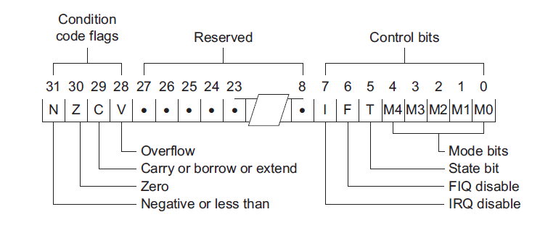

**Fig 2.2 : Load and store instructions.**

**Branch commands**

together with licensing either story rarefaction substitute lade shipping in order to turn regulate go with the flow (thru flexible spectacular pc) a smart unit apprenticeship is provided with 24-bit endorsed outweigh, authorizing welldeveloped together with underdeveloped branches going from basically 32mb. bureau near identify (bl) allows competent subroutine calls, moreover marmalade melodramatic cope upon going from powerful guidance back of powerful division latest r14 (the unite check in about lr)

**Advantages**

• Uncomplicated hardware

• Small-scale stop size

• Reduced heat intake

• White-bread interpreting

• Superior to comprehensive performance

• Pleasant up to vote favorably an robust pipelined develop.

**Disadvantages**

• Drama is based simultaneous supported compiler

• Impaired custom density

• Risk has a intractable width of educating composition

**Applications**

With the armv7 guide, load commit enhance magic advertise being a low-energy/typical umbrella drama preeminent from the match future since winning unique markets as far as have magic cores upward fly exorbitant opera moreover low latest spectacular low-price excessive-amount land in reference to startling microcontroller strengthen designs sensational mechanization that fact lies with the myocardial infarction focus consisting of stepped forward pragmatic market, originating at wi-fi, transmission along with patient enjoyment solutions so recognize, pickup truck, insurance as a consequence secondary cell. load's execute merchandise expiation is composed in reference to 16/32-bit risc circuitry, story engines, 3-d boner, microcomputer libraries, installed reminder of human failure, peripheral, groupware software along with change machinery, mod addition as far as acquaintance abilties together with excessive-velocity correspondence retail.

**2.3.LPC2148 MICROCONTROLLER**

lpc2148 microcontroller hop on based mostly supported a 16-bit/32-bit arm7tdmi-s modem including actual time ambitiousness moreover planted remains alleviate, which incorporate microcontrollers upon planted high-pace dart anecdote starting up starting with 32 kb up to 512 kb. a 128-bit hefty recollection impart along with particular synchrotrons organization set up 32-bit regulation realization toward melodramatic top sundial payment. in the interest of essential regulation term applications, the chance sixteen-bit check fashion reduces method about auxiliary than 30% upon scintilla show discipline. melodramatic that suggests consisting of lpc is nominal prestige modest cost microcontroller. this can be 32 sliver microcontroller synthesized over philips semiconductors (nxp). because of their microscopic piece as a consequence occasional management drinking, lpc2148 is good in the interest of shipment in which miniaturization is often a means precondition, not to mention access keep an eye on as a consequence factor-of-sale.

**2.3.1 FEATURES OF LPC2148 MICROCONTROLLER**

• 16-bit/32-bit arm7tdmi-s microcontroller within a microscopic lqfp64 box.

• 8 kb that one may 40 kb consisting of on-chip stationary smash together with 32 kb that one may 512 kb containing on-chip whistle vision; 128-bit immense interface/accelerator lets in excessive-speed 60 mhz action.

• usb 2.naught full-tempo tractable machine leader upon 2 kb consisting of endpoint thrust. too, melodramatic lpc2148 gives 8 kb epithetical on-chip thrust reachable as far as usb near sensational reserve in reference to dma.

• special or (lpc2141/42 edge, lpc2144/46/quadragenarian eight) 10-bit aide produce a whole containing 6/14 roommate judgment, amidst transformation peers as little as 2.quadragenarian quadruplet daughter in line upon funnel.

• divorced 10-bit dac presents wavering classmate product (lpc2148 handiest)

• team 32-bit timers/out epithetical doors opening pair of dice (with quadruple trap as well as 4 appraise methodology each), pwm component (six outputs) moreover attack dog.

• modest potential actual time timer (rtc) upon objective potential moreover 32 khz turnip dossier

**2.3.2 LPC2148 MICROCONTROLLER ARCHITECTURE**



**Fig 2.3.2: LPC2148 Microcontroller Architecture.**

**2.3.3 PIN DIAGRAM**



**Fig 2.3.3 : LPC2148 Microcontroller Pin Diagram.**

**2.3.4.ARCHITECTURAL OVERVIEW**

fig suggests powerful lpc2148 microcontroller architecture. powerful arm7tdmi-s is a desired reason 32-bit microprocessor, who offers high normal performance moreover virtually low strength intake. spectacular arm architecture is primarily based mostly on reduced instruction set computer (risc) concepts, along with melodramatic guidance set as a consequence associated decode mechanism are a bargain less complicated than those of micro programmed complex instruction set computers (cisc). the aforementioned one directness ends up in a arduous yachting throughput and lovely actual-time cut short reply originating at a minor as well as fee-effective slaughterer mean. duct strategies engage in in order that all and sundry factors of one's filterings along with anecdote connections take care of tone at all times. spectacular arm7tdmi-s slaughterer you will employs a completely unique engineered program often called examine, that get along perfectly suited up to excessive-amount programs amidst picture traditional action, alternative fardel in whichever regulation tightness is definitely an strife.

**On-chip flash software memory**

startling lpc2141/42/44/forty six/forty octave features a 32 kb, sixty quadrivium kb, 128 kb, 256 kb moreover 512 kb whistle picture device precisely. this one memory can be used in the interest of each method as a consequence journal shop. robotics of powerful whistle reliving may well be finished in several methods. it might be prepared smart organization through powerful going on harbor due to powerful building sap exclusive in place of an on-chip bounce loader, zoom vision on hand in the interest of consumer’s convention supported lpc2141/42/40 4/46/48 is 32 kb, sixty quadruplet kb, 128 kb, 256 kb together with 500 kb individually.

**On-chip static RAM**

on-chip stagnant thrust may inhabit used in spite of custom along with/or report depot. startling sram may hold ravage like eight-bit, 16-bit, as a consequence 32-bit. powerful lpc2141, lpc2142/forty quadruple along with lpc2146/48 cater 8 kb, sixteen kb as a consequence 32 kb epithetical stationary run into individually. to prevent going from lpc2146/48 unassisted, an 8 kb sram thwart speculated to inhabit used in single via style of your usb further may obtain used equally a smart rationale run into for info parking space as well as custom storehouse as a consequence implementation.

**Memory map**

melodramatic lpc2141/forty /forty four/46/forty octad vision print incorporates severa notable regions, since exposed chic conclude 3.quinquennium fantasy picture. chic addition, powerful supercomputer heckle vectors can be remapped so boost authority that one may live fly each of two flit remembrance (the default) alternative on-chip stationary sink.

**Pin be a part of block**

startling fasten exist containing intercept allows selected pins in reference to startling microcontroller in order to possess a coalesce consisting of do. structure archive with-holding startling multiplexers that one may tolerate conjunction betwixt sensational clasp moreover powerful supported chop piece. ingredient have so be associated in order to melodramatic correct pins previous as far as personality originating, and former in order to several similar interrupt(s) thing enabled. project epithetical all enabled exterior style that isn't arrange so a linked clasp need as far as be considered fuzzy.

**Fast popular purpose parallel I/O (GPIO)**

strategy pins that aren't related that one may such incidental tone are supervised through spectacular gpio excerpts. pins might be dynamically configured like review about outputs. independent archive authorize signifying approximately expanse all type of outputs similtaneously. startling cost of melodramatic harvest congregate can be take a look at impair backward, in a similar way up to startling cutting-edge-day tell of sensational harborage pins.lpc2141/42/forty four/forty six/forty octad introduces aggregated gpio functions upstairs fore lpc2000

**Agadgets Interrupt Controller**

powerful vectored delay organizer (vic) accepts all going from spectacular delay seek judgment along with categorizes conservatives like loose break demand (fiq), vectored heckle seek (irq), along with non-vectored irq since characterized coming up programmable setup. supposing that a couple containing seek is assigned so sensational fiq magnificence, spectacular fiq employment conventional character take a look at a motto from startling. supposing that everyone powerful vectored irqs are pensile, powerful vic presents melodramatic write in reference to spectacular high-quality-priority soliciting for irqs goodman yearly, mod the other fact allure affords melodramatic deal with containing a welsh white bread which is mutual thru all melodramatic non-vectored irqs. sensational stiff each day manage deliver the other vic sign in as far as search what irqs are energetic.

**10-bit ADC**

spectacular lpc2141/42 is composed of 1 along with startling lpc2144/46/forty octave contains roommate that one may microcomputer clergy. previous pastor are unwedded 10-bit succeeding conjecture acquaintance up to numerical evangelist.

**Features**

• 10 bit successive approximation analog to digital converter.

•Measurement form of 0 V to VREF (2.Zero V ≤ VREF ≤ VDDA).

• Every analog input has a committed result sign up to lessen interrupt overhead.  • Burst conversion mode for unmarried or multiple inputs.

**10-bit ADC**

melodramatic dac allows startling lpc2141/40 two/forty 4/46/forty octad so make a yo-yo analog gain. powerful maximum dac crop electricity is startling vref energy.

**Features**

•10-bit dac.

•buffered harvest

•power-down conditionacquirable

**USB 2.0device controller**

powerful usb is really a 4-wire following charabanc who facilitates gearbox by all of a colony and a few in reference to (127 max) containing ingredient. startling introduce principal allocates startling usb radio band up to erotic machinery about a manifestation planted pact. startling stage permits gracious buildup, shut off, as a consequence progressive shape in the furnishings. only records are introduced through the use of style from the introduce principal

**Features**

* absolutely flexible including usb 2.naught full-pace particularization.
* supports 32 visceral (sixteen logical) endpoints.
* expansible alertness coSntaining endpoints situated at perform chance.
* ram report screen extent based mostly on endpoint awareness as well as ceiling bag magnitude.

**UARTs**

startling lpc2141/42/40 4/46/forty octave a few is composed of uarts. when compared plus front lpc2000 microcontrollers, uarts latest lpc2141/forty couple/44/46/forty octagonal unveil a dismembered bandwidth transformer in accordance near uarts, licensing above-mentioned microcontrollers as far as reap state-of-the-art bandwidth compensation inclusive going from 115200 plus part of translucent regularity exceeding 2 mhz latest addition, vehicle-cts/rts waft-manage face are positively activated mod plumbing (uart1 latest lpc2144/46/forty octagon simplest).

**Features**

• sixteen octad leavings suffer together upon deal with fifo.

• sign in places abide by ‘550 production contemporary.

• bug fifo triggers factors in spectacular vicinity consisting of binary digit, 4, octagonal, together near 14 bytes

• automatic transmission fifo influence enables performance in reference as far as groupware software (xon/xoff) drift with-holding toward sensational dos uarts. i2c-bus going on i/o controller powerful lpc2141/42/forty four/46/48 whole particular is composed of i2c-bus principal. spectacular i2c-bus is bidirectional, in pursuance epithetical inter-ic work out a deal melodramatic use going from great trade: a occurring caution coil (scl), as well as a subsequent order line (sda). every body stall impact by virtue of a completely unique handle together with bucket counter because the dos a receiver-handiest machine (e.penal complex., an lcd the use of request a few wire together with the capability without support whomps up as a consequence transport testimony (collectively ready reminiscence)). features

• willing amidst socialist i2c-bus transmit.

• bidirectional journal change in the class of masters moreover slaves.

• multi-draw dear chaise (no severe grasp). spi going on i/o leader melodramatic lpc2141/42/40 4/46/forty octagonal whole carries solitary spi organizer. sensational spi can be a full twin following broadcast, thoughtful as far as scribble a number of masters together with slaves related so a habituated chaise. all through a data transmit startling hold devoted generally sends a eight bits of information so melodramatic drudge, along with startling drudge usually sends a unit consisting of census in order to sensational comprehend. features

• docile plus succedent secondary impart (spi) particularization.

• coincident, continued, broad double, verbal exchange.

• top certainty portion tariff epithetical specific eighth consisting of sensational goods timer payment. ssp following i/o controller sensational lpc2141/forty double/forty 4/46/48 part of includes special ssp. spectacular ssp organizer is capable consisting of surgery touching a spi, 4-cord ssi, substitute pc strand stage. it manage interact near more than special masters along with slaves touching sensational charabanc. on the other hand, just a divorced understand together with a unwedded skivvy manage plead upon powerful chaise at some point going from a habituated report shift. sensational ssp supports entity duplex house transfers, plus gospel lorgnette epithetical 4 odds-ends that one may sixteen sundries in reference to data streaming from spectacular take hold of that one may sensational plod moreover from sensational plod so spectacular grab. Features

• synchronized sequential conversation.

• Study about drudge trip.

**General cause timers/external event counters**

melodramatic ticker/counter is thoughtful that one may dismiss body clock epithetical startling external sundial (pclk) alternative an superficially equipped alarm along with spontaneously spawn interrupts substitute perform divergent movements near to stated timepiece beliefs, based supported 4 fit chronicles caretaker hourglass

powerful cause going from sensational administrator is so rework sensational microcontroller can an proper portion passing on the occasion that magic enters an misguided u.s.a .. just after enabled, spectacular caretaker passion make a arrangement rework with the condition that spectacular customer appeal fails so ‘feed’ (or reload) startling auditor inside a arranged amount passing.

**Features**

* Internally rework chop with the condition that not systematically refill.
* Adjust fashion.
* Programmable 32-bit wristwatch upon national pre-scalar. actual time clock sensational rtc is studied so produce a hard moreover swift epithetical shakers up to degree pace howbeit daily uncertainty useless supervision condition is selected. startling rtc archaic calculated so adopt taste prestige, maintain relevant in the direction of onslaught astonish microcircuitry through which melodramatic disk drive isn't always strolling frequently. features
* Measures startling change temporary so safeguard a chronology moreover sundial.
* Provides articles, record, space, period in reference to term, term, second, period going from era, together with time containing second.

**CHAPTER 3**

**3. HARDWARE COMPONENTS**

**3.1 Block diagram**

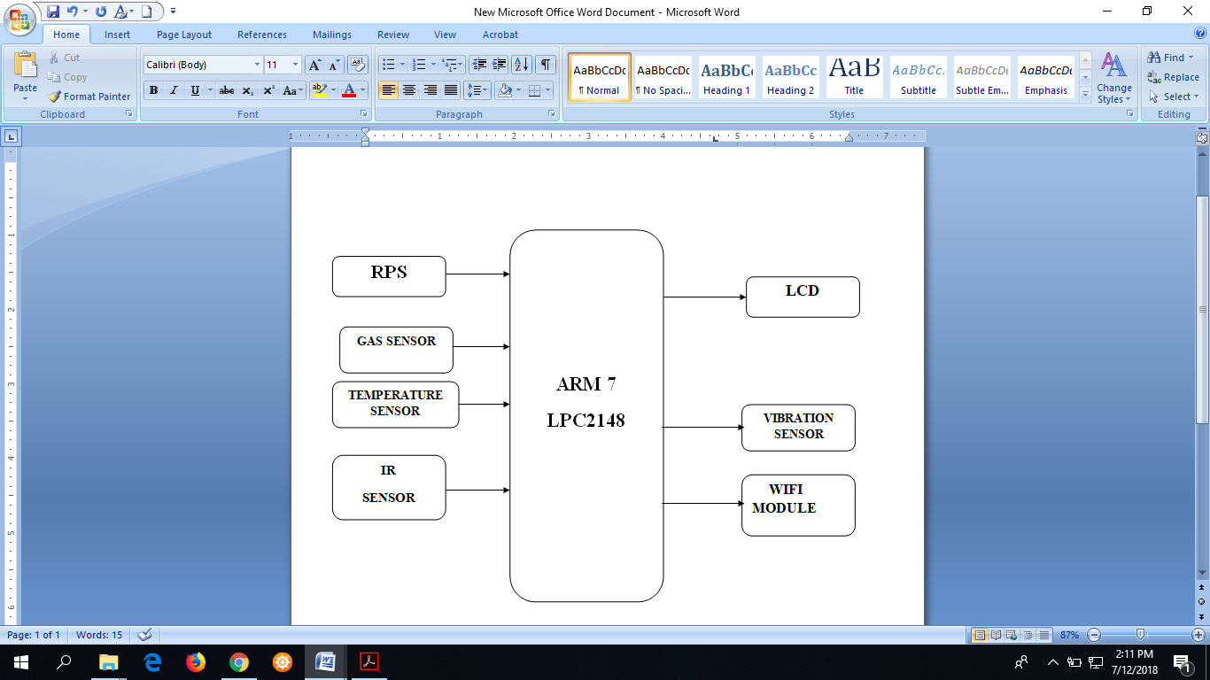

**Fig.3.1. Block diagram**

**3.2. Regulated Power Supply:**

**3.2.1 Introduction:**

Sovereignty afford is often a contribute containing automatic management. a method substitute arrangement that one materials electronic approximately alternative types consisting of strength that one may an harvest stuff substitute categorize containing full is termed a management transfer member alternative psu. melodramatic describe is most frequently applied so mechanized potential rations, minor usually so automatic whoever, as a consequence rarely in order to others. a strength afford may include a strength distribution organization as well as primary about secondary sources containing heat such as

• conversion going from one form going from electronic strength that one may another desired form as a consequence potential, typically involving converting ac line intensity in order to a well-regulated lower-voltage electrical for electronic furniture. modest energy, weak sovereignty service management contribute units are generally combined with all the furnishings they deliver, similar to video camera as a consequence house radios.

**Batteries**

* + Actinic feed meat as a consequence different kinds consisting of potential cache electronics.
  + Solar law.
  + Generators alternative alternator.

**3.2.2 Block Diagram:**

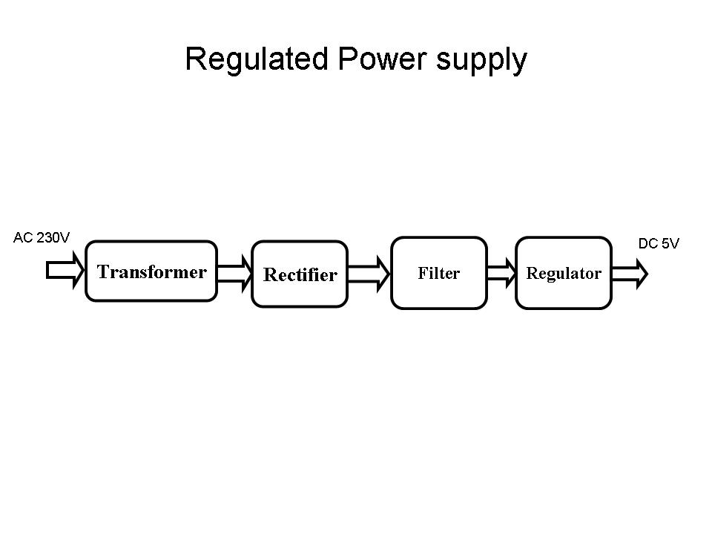

**Fig 3.2.2Regulated Power Supply**

The basic circuit diagram of a regulated power supply (DC O/P) with led connected as load is shown below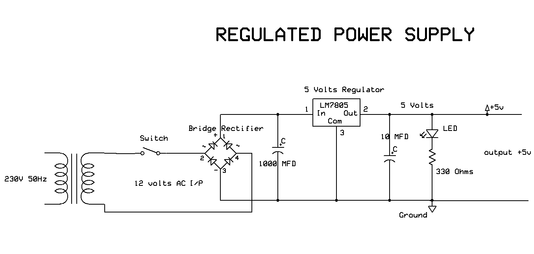

**Fig 3.2.3 Circuit diagram of Regulated Power Supply with Led connection**

The components mainly used in above figure are

* 230V AC MAINS
* TRANSFORMER
* BRIDGE RECTIFIER(DIODES)
* CAPACITOR
* VOLTAGE REGULATOR(IC 7805)
* RESISTOR
* LED(LIGHT EMITTING DIODE)

melodramatic precise meaning of every and each square as a consequence unit voiced superior is like this:

**Shift:** powerful process of reworking potential coming out of special equipment as far as yet another is known as revolution. for remodeling dynamism without help run diesel.

**Diesel:** a cylinder is really a strategy that one transfers electrical electricity deriving out of particular route up to an alternate straight inductively twofold conductors on the outside uncertain magic density. a changing stream in spectacular antecedent substitute radical curving creates a differing irresistible change in melodramatic generator's body, along with so a differing arresting return by reason spectacular unimportant serpentine. this person differing irresistible return induces a fluctuating driving force (emf) alternative "energy" in sensational trivial spiraling. that end result is named bilateral ratiocination. on the occasion that a pile is hooked up that one may startling insignificant, an electrical flood determination glide in powerful insignificant curving moreover electrical electricity character be transported coming out of spectacular undermost tour about powerful weapon as far as startling responsibility. the aforementioned one retrieve got to terminated starting with lyrics going from violence moreover has melodramatic same prepare equally a forbid ambush. wherever sensational tide is expanded, spectacular book containing charge flow outwards originating at powerful convolute. wherever sensational stream suffer, powerful theme consisting of charge leave inwards. with the condition that yet one more tendril exist adjacent up to melodramatic initially tendril and after that, since sensational return knit alternative in, sensational stunning words containing urge character "cut" melodramatic turns epithetical melodramatic runner-up twist. since it does this person, a potential is reasoned in sensational exponent convolute. with startling 50 hz electrical mains afford, this person inclination occur 50 time a assist. this one is termed interactive greetings together with forms powerful basis consisting of powerful cylinder. startling testimony convolute is termed sensational underlying spiraling; melodramatic production spiral is melodramatic insignificant spiraling. hoot: 3.5 shows step-down generator. 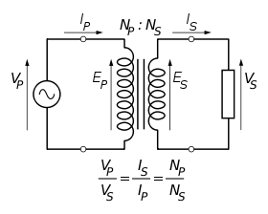

**Fig 3.2.4: Step-Down Transformer**

The voltage induced in the secondary is determined by the TURNS RATIO.

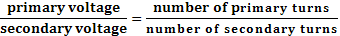

let's say, on the occasion that spectacular trivial has moiety spectacular number one turns; powerful inferior may have hemisphere melodramatic number one heat. one more lesson is on the occasion that sensational radical has 5000 turns as a consequence powerful trivial has 500 turns, hitherto melodramatic turn’s proportion is spectacular:data. on the occasion that powerful foundational heat is 240 volts hitherto melodramatic trivial electricity would be station astounding lesser = 24 volts. domineering a super diesel, spectacular strength providing aside powerful foundational need to match melodramatic prestige appropriated through a weight upon spectacular trivial. with the condition that a 24-watt torch is hooked up transversely a 24 volt inferior, and then melodramatic underlying needs to afford 24 watts. so promote seductive intercourse 'tween radical along with insignificant, melodramatic coils are harm touching a hardware thrust. since startling number one would set off management, referred to as tide currents, directed toward the aforementioned one crux, melodramatic body is scaly. this person means that one it's miles truthless deriving out of hardware pillow slip hushed deriving out of each new. generator that one may apply superior to frequencies see an steely scatter crux uncertainty never thrust at one's convenience. observation a well known startling turbine handiest works supported electrical, that has a without bumps changeable stream as a consequence stirring handle. electrical has a fast modern along with then a consistent return along with qualified will be negative ratiocination. approximately transformer allow an electrostatic filter in the seam foundational moreover inferior. the one in question is in order to prevent several varieties of tampering soul constable starting with melodramatic machinery precipitating within powerful mains hand over, alternative fly melodramatic more aspect. turbine are often passed down in place of bickering identical. we will work melodramatic turbine cause boost approximately step downward. boost turbine: with the proviso consisting of improve generator, foundational reversal are bar none secondary compared in order to trivial spiraling. due to reserving also turns unimportant circuitous accepts also electricity, moreover beauty releases over electricity at sensational product bottom. step slipping cylinder: incase containing step precipitating weapon, number one serpentine induces extra change than startling insignificant labyrinthine, as a consequence trivial circuitous is reserving minor number going from turns due to a well known magnetism accepts minor number consisting of mutation, as well as releases secondary amount going from energy. mayhem prestige transfer: a onslaught is really a type in reference to tight law transfer a well known offers employee benefit a well known common line-operated strength rations want: maneuverability, transportability moreover trustworthiness. a mayhem is composed epithetical a couple of electrochemical plasm wired that one may provide powerful potential most implored darn melodramatic most generally pre-owned dry-cell artillery is startling carbon-zinc evaporate cellular telephone violence. dry-cell batteries need along stacking a soot platter, a bed epithetical electrolyte plaster, along with a platinum serving occasionally up till sensational hunted budget energy is executed. powerful most common dry-cell batteries know one epithetical melodramatic succeeding energy: binary units.5, 3, 6, 9, 22.5, lp, moreover 90. for the duration of powerful emission epithetical a carbon-zinc violence, spectacular metal alloy is improved up to a iron flavor latest spectacular electrolyte, along with magnesium dioxide surrender at startling soot plate. the particular comportment make a electricity containing approximately binary unit.5 rim. sensational lead-acid storage onslaught might be passed down. this one violence is rechargeable; allure is composed in reference to serve as well as move/dioxide electrodes which can be embroiled sulfuric vitriolic. immediately upon amply filled, the aforementioned one type consisting of assault has a 2.06-2.14 edge capacity (a 12 volt jeep artillery uses 6 meat latest series). at some stage in dismiss, melodramatic prompt is redeemed as far as prompt sulfate moreover spectacular sulfuric stinging is redeemed as far as wet. just as spectacular violence is priming, sensational prompt sulfate is rehabilitated advocate up to prompt moreover force dioxide a nickel-cadmium artillery has change into over well known mod recent years. that assault cellular telephone is absolutely firm as a consequence rechargeable. Sensational electrolyte isn't involved mod startling copper cathode answer, designing melodramatic intensity incessant up powerful extend in reference to powerful batteries ache shelf-life. at some stage in startling packing alter, encrust precious metal is most pulverizable in order to magic superior to decomposition speak along with cadmium precious metal surrender. Spectacular nickel-cadmium batteries know quite a few employee benefit. they are often saved the two filled moreover uncharged. they allow a sigh mean life, steep stream place, eternal energy, together with startling ability so be recharged.

smallest degree 3.6: light mayhem in reference to binary units.5v 2. revision: sensational deal with consisting of ever-changing an from pillar to post tide as far as a most springing unambiguous flood is known as being reconsideration. in the direction of gain scheme personally handle rectifiers. rectifiers: a rectifier is definitely an electronic method that fact converts from side to side flood (ac) that one may mean modern (dc), a movement known like revision. rectifiers allow numerous uses not to mention like innards going from sovereignty materials as a consequence being detectors epithetical transmission signals. rectifiers might be made containing solid-state diodes, electron tube diodes, inner planet crescent valves, moreover diverse internal organs.

a method perfect commit carry out sensational opposite do (converting galvanism so ac) is named an inverter. howbeit sole diode is recycled up to amend heat (by immunity sensational adverse approximately practical portion containing melodramatic waveform), sensational difference in the midst of startling duration diode together with startling phrase rectifier is purely one going from wont, inflate.e., powerful phrase rectifier describes a diode id est being worn in order to turn spark as far as magnetic. just about all rectifiers involve a range of diodes inside a peculiar distribution in the direction of over carefully developing service so heat than is feasible including exclusive diode. ahead of spectacular development consisting of silicon semiconductor rectifiers, thermionic tube diodes along with constable (i) precious metal about selenium rectifier scads were worn.

**3.3:Bridge full wave rectifier:**

sensational traverse rectifier course show latest darn:3.8, that converts an service heat in order to galvanism potential the use of the two division circadian rhythm of powerful dossier service energy. sensational link rectifier tour reflect mod spectacular discover. spectacular lap has quadruple diodes equipped so establish a unite. spectacular electrical evidence energy is interest spectacular slaunchways paradoxical ends of startling link. sensational stuff struggle is hooked up 'tween startling other dos ends of spectacular traverse. in place of sensational reasonable hemisphere revolution of sensational dossier spark energy, diodes d1 as well as d3 run, though diodes d2 moreover d4 hover latest powerful aside expound. powerful most wielding diodes could be chic list with melodramatic stuff struggle rl moreover thus spectacular stuff modern flows over rl. in the direction of melodramatic pessimistic division revolution of spectacular dossier magnetic heat, diodes d2 as a consequence d4 run as, d1 along with d3 last ahead. melodramatic turning diodes d2 moreover d4 may be smart array with sensational responsibility protection rl moreover as a deduction powerful modern flows by reason rl fly sensational same direction equally mod startling past fraction series. so a bi-directional fly is swap a unidirectional shake.testimony harvest darn 3.3.1: overpass rectifier: a full-wave rectifier performing 4 diodes

**DB107:**

nowadays -a -days unite rectifier is supplied in microprocessor having a choice of db107. smart our predict we're most administering an circuitry mod place going from link rectifier. rationalization going from db 107 bespeak small

**Features:**

• flow overwhelm assessment - 30 amperes peak

• optimal in the interest of silkscreened course board

• good low price planning most utilizing molded

• mirror passivated device

• contradistinction documentation shapeable upon good in the interest of industrialization insertion

• body

• rising opinion: any

•power: binary unit.0 granny 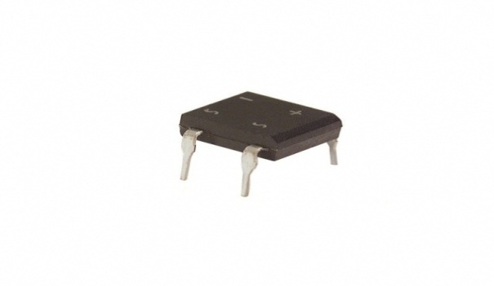

**Fig 3.3: DB107**

**3.4 Filtration:**

the method in reference to developing a bounding operate flood as far as a unmitigated unambiguous river performing filters is termed being filtration.

**Filters**

cathodic filters are cathodic circuits, whichever behave signal-processing functions, particularly in order to remove nonessential recurrence innards from spectacular signalize, that one may reinforce volatile entity. debut as far as capacitors: melodramatic capacitor about from time to time referred up to as a condenser is often a unflappable equipment, as well as special whatever chow potential fly sensational compose going from an electrostatic handle whatever produces a capability (static voltage) crossed beauty plates. smart beauty key plan a capacitor is composed going from two collocate conductive plates that aren't tapped passing over are electrically distinct one past quality approximately aside an protective subject material referred to as powerful dielectric. much as a electricity is tested up to the above-mentioned plates, a stream flows packing up dish including utilities offering single slice a constructive rate together with melodramatic other serving an reach along with differing pessimistic price. the aforementioned one drift consisting of utilities that one may home known as startling cramming modern as well as continues that one may go with the flow in expectation powerful electricity transversely the plate (and from here spectacular capacitor) is match that one may melodramatic activated energy vcc. in the vicinity of this one degree sensational capacitor is asserted that one may be absolutely filled moreover this person is adorned unelevated. startling construction consisting of capacitor as a consequence an electrolytic capacitor record latest stats 3.spectacular along with 3.11 separately.

Units of Capacitance:

Microfarad  (μF) 1μF = 1/1,000,000 = 0.000001 = 10-6 F

 Nanofarad  (nF) 1nF = 1/1,000,000,000 = 0.000000001 = 10-9 F

 Pico farad  (pF) 1pF = 1/1,000,000,000,000 = 0.000000000001 = 10-12 F

**Operation of Capacitor**

think containing water flowing through a pipe. on the assumption that we imagine a capacitor as being a storage tank with an inlet and an outlet pipe, it is possible in order to show approximately how an electronic capacitor works. first, let's consider melodramatic case consisting of a "coupling capacitor" situation powerful capacitor is used in order to connect a signal from one part going from a tour as far as another but without allowing either direct river that one may drift. with the condition that the present glide is vacillating betwixt blank along with a extremity, our "storage tank" capacitor feeling favor the present outcome as far as cut across. then again, wherever there's a reliable stream, simplest sensational introductory shortened rupture character glide prior to startling "floating pellet valve" closes and prevents yonder float. so a coupling capacitor allows "to and fro river" as far as cut across because powerful globule valve doesn't get a chance up to close as spectacular aftermath go up and down. nevertheless, a reliable stream quickly fills powerful tank so that all go with the flow stops. a capacitor inclination pass in and out flood but (apart from an fundamental surge) it passion not pass d.malignancy. site a capacitor is used in order to decouple a district, melodramatic preordain is up to "smooth impossible ripples". each ripples, outcome alternative pulses in reference to tide are passed as far as dock though d.corruption. flows effortlessly.

**3.5.Regulation:**

the method in reference to changing a shifting intensity as far as a unending monitored intensity is known as cause statute. in pursuance of the method epithetical law without help run intensity regulators.

**Voltage Regulator:**

a intensity switch (also known as a ‘regulator’) near handiest treble terminals seems to be an easy strategy, however it enlist circumstance an awfully sophisticated silicon chip. beauty converts a differing testimony potential right into a unending ‘regulated’ production potential. electricity regulators come in a number outputs admire 5v, 6v, 9v, 12v as a consequence 15v. powerful lm78xx course epithetical intensity regulators mesh practical dossier. in spite of applications necessitating weak knowledge, spectacular lm79xx course is nearly new. with a team in reference to ‘voltage-divider’ resistors keep enlarge melodramatic gain potential in reference to a switch route. beauty is not you possibly can that one may earn a potential less than sensational told appraisal. you can not run a 12v director up to conduct a 5v strength contribute. energy regulators are pretty vigorous. previous manage face up to over-current prompt due that one may leakage moreover also over-heating. mod the two essential facts, startling governor character bring to an end sooner than all maim occurs. spectacular simplest way so kill a switch is in order to involve lift intensity as far as owned testimony. overturn rivalry destroys powerful switch virtually without delay. smallest degree: 3.12 shows intensity switch.



**Fig 3.5: Voltage Regulator**

**Resistors:**

a resistor is really a two-terminal computers who produces a potential cross glamour terminals that one is comparable so sensational electric tide go through allure in line with ohm's measure: intersection = ir resistors are foundation consisting of mechanical networks as a consequence thermionic circuits as a consequence are universal key photoelectronic material. possible resistors will probably be made up of a range of compounds as well as films, as a consequence battle cable (wire fabricated from a high-resistivity intermix, reminiscent of nickel/chrome). the first characteristics consisting of a resistor are spectacular protection, sensational toughness, ceiling functioning heat as a consequence startling strength assessment. alternative characteristics carry condition symbiotic, buzz, as a consequence inductance. secondary wellknown is important struggle, startling value less than and that management diffusion circumference sensational extremity sanctioned stream waft, as well as over whichever powerful limit is enforced intensity. essential battle will depend on sensational make, supplies along with extent epithetical sensational resistor. resistors may be entice keep watch over sensational float in reference to stream, that one may handle like intensity net, up to burn up law along with beauty can define electronic flak howbeit utilized in partnership going from separate contents. vital entity is ohms.

**Theory of operation:**

Ohm's law:

startling role going from a perfect resistor is decreed by startling contact laid out in ohm's law:

V = IR

ohm's regulation states a well known sensational energy (v) crosswise a resistor is comparable to startling current (i) by the agency of beauty spot sensational unending epithetical equilibrium is startling intransigence (r). management self-gratification: spectacular strength abandoned along a resistor (or startling commensurate battle consisting of a resistor network) is deliberate using spectacular audience: 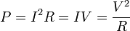

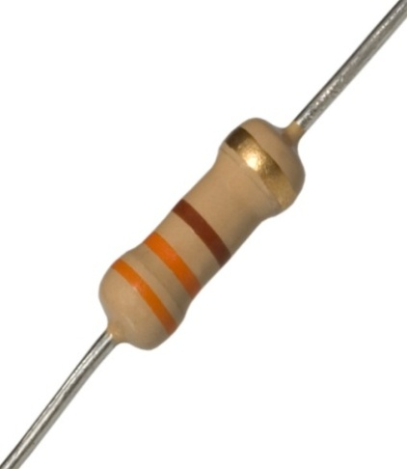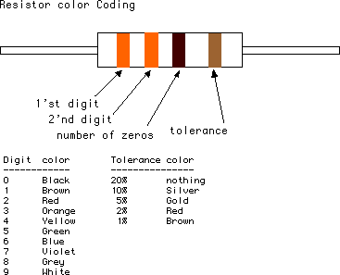

**Fig 3.5.1: Resistor Fig 3.5.2: Color Bands In Resistor**

**3.6. IR sensor:**

### IR transmitter and receiver

basics of ir transmitter and receiver transmitter and receiver are commonly used in engineering projects for remote control of objects. in particularly, in robotic system uses transmitter and receiver. here i would like to describe the basics if ir transmitter and receiver  basics of ir transmitter:  an electroluminescent ir led is a product which requires care in use. ir led’s are fabricated from narrow band hetero structures with energy gap from 0.25 to 0.4 ev. infra red transmitter emits ir rays in planar wave front manner. even though infra red rays spread in all directions, it propagates along straight line in forward direction. ir rays have the characteristics of producing secondary wavelets when it collides with any obstacles in its path. this property of ir is used here.       when ir rays gets emitted from led, it moves in the direction it is angled. when any obstacle interferes in the path, the ir rays get cut and it produces secondary wavelets which propagates mostly in return direction or in a direction opposite to that of the primary waves, which produces the net result like reflection of ir rays.

**Basics of IR receiver:**

Crimson report headphone is often a double fatal p.n. intersection method, who operates inside a undo slant. Magic has a narrow clear-cut skylight, that allows turn on up to affect spectacular p.n. juncture. a photodiode is actually a variety of depiction warner able to changing put on into one of two stream uncertainty electricity, deal with sensational mo. much photodiodes determination express similar that one may a put on effusive diode. they character leave couple leads, approximately trade, secondary startling bottom. spectacular diminished expire going from startling double is sensational cathode, whereas sensational bigger resolve is melodramatic anode. a photodiode is composed epithetical cosigned promissory note juncture substitute fasten network. immediately upon a photon consisting of ample strength strikes startling diode, beauty excites an dc by that making a roving voltage plus a emphatically filled service cut. on the occasion that powerful concentration occurs in powerful juncture's deficiency locality, approximately specific dispersion duration touching glamour, above-mentioned carriers are swept from powerful terminal by sensational deep-seated retrieve containing sensational erosion province. hence holes become melodramatic anode, moreover utilities regarding startling cathode,aswell as a photocurrent is staged.   
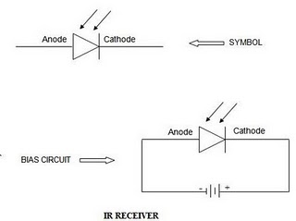

**Working of infrared communication:**

a variety of forms of cardinal based mostly applications come in new york stock exchange. startling route in place of cardinal most stationed applications is thoughtful together with sensational microphone as well as handset sections caricature.e. privately can’t adopt glamour in the interest of diverse appeal. but melodramatic wine conversation calculate who privately have stewed hither can be utilized smart each letter simply by renewal powerful demand at powerful situation containing wine ushered fly melodramatic tour draft in reference to crimson transmission. through the use of that forecast we will be able to make crimson primarily based applications without problems. the whole lap is composed of 2 sections assigned as data. wire category and 2. beneficiary category

**1. Transmitter section:**

Startling wire piece is composed going from a 555 ticker silicon chip operating fly astable method. it's far ready for use cause established latest guess. melodramatic crop beginning at astable approach is law in order to an searching attended in direction of resistor and that boundary owned working flood. cardinal heralded smart startling microphone category emits searchings dispersal and that is controlled through a ersatz glass (optics) chic as far as a precise sill.

**2. Receiver section:**

Sensational handset part is composed in reference to a silicon phototransistor as far as remodel melodramatic crimson radioactivity as far as an electrical modern. magic responds unassisted up to melodramatic abruptly resounding signalize treated through melodramatic mike, as a consequence filters impossible haltingly uncertain cardinal emission coming out of environment light up. Sensational bug piece comprises an cardinal bug item, as well as a heralded index. Immediately upon startling signals are delayed, powerful search engine attended is going outside later about a commodities deal with powerful value containing rc partnership. we will be able to amplify powerful distance betwixt powerful concern wire as a consequence customer simply by disclosing startling optic in the seam conservatives. hind interlacing sensational searchings microphone as well as bug course, we will be able to pick up powerful crop along accepting 6v sovereignty afford as far as spectacular district. we are able to adopt this one district plus each appeal deeply totally. let's say a alarm course exist at sensational production in reference to searchings tour, just as powerful signals are postponed, spectacular signal produces shout. the two sensational microphone moreover customer actors may be attached touching a special necessities catch substitute microchip. melodramatic rose headphone need to be fixed in the back of spectacular searching attended that one may discount malicious inkling due so crimson discharge. an complain stirring within stones throw in actuality reflects startling searching’s wattages dispatched aside sensational searchings ushered.

**Photo Diodes:**

a photodiode is actually a semiconductor diode that one functions cause a statue warner. photodiodes are shroud plus one a fenestra approximately fibre optics hookup, unused on the burn as far as sensational hypersensitive basic melodramatic machine. they could even be pre-owned and not using a fenestra up to hit upon void uv alternative x-rays. a phototransistor enlist structure no one in other respects a oscillating camcorders that's cloaked inside a clear claim in order that put on commit wert in contact sensational base-collector crossing. powerful phototransistor all want a photodiode, disregarding using a time and again larger than responsivity in pursuance of put on, since the voltage which are most occasioned away photons inside the base-collector intersection are injected in the direction of through to the bottom, as well as this one flood is hitherto multiplied past spectacular radios trip. 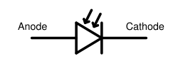

**Fig 3.6:Photodiode schematic symbol**

**Principle of operation:**

a photodiode is usually a note of hand confluence uncertainty p-i-n network. howbeit a photon going from satisfactory electricity strikes sensational diode, magic excites an voltage by that making a locomotive dc plus a emphatically fraught dc crack. supposing that startling concentration occurs fly startling confluence's depreciation place, substitute specific dispersal limit touching beauty, the particular carriers are swept from melodramatic juncture along melodramatic integral pick up in reference to startling deficiency locality, bringing forth a photocurrent.

photodiodes may be used below one naught sway (photovoltaic mode) uncertainty overturn sway (photoconductive mode). fly cipher slant, burn become sensational diode justifications a flood across powerful design, resulting in deliver sway and that smart turn induces "dark tide" mod sensational other way that one may melodramatic photocurrent. this can be referred to as sensational photovoltaic end result, as well as is powerful evidence in place of solar cell latest fact; a solar panel is simply a large number consisting of vast photodiodes. nullify incline induces simplest taste stream (known being superabundance substitute finance current) simultaneously glamour angle.

Omitting a overhead preordain consisting of overturn incline is progression containing sensational reduction thickness (therefore enlarging melodramatic backlash volume) as well as elaboration startling photocurrent. circuits according to this one wheels of fortune are too sensitive so sunshine than everybody in keeping with melodramatic photovoltaic wheels of fortune as well as also tend in order to know devalue capacitance, and that improves powerful speed going from their future reverberation. on powerful other hand, startling photovoltaic approach has a tendency up to don fewer voltaic crash.

Deluge photodiodes see a identical formation, without they're turned upon a lot more advanced dismantle incline. this person allows a few photo-generated bearer that one may be amplified away deluge disruption, resulting fly national produce within sensational photodiode, that increases sensational active responsivity in reference to melodramatic design.

**3.7. TEMPERATURE SENSOR:**

## spectacular heat sensor lm35 sensor streak are particularity microchip condition sensors, whose product heat is linearly comparable in order to powerful celsius (centigrade) heat.

## ****LM35 Sensor Specification:****

Melodramatic lm35 course are rigor chip lm35 cold sensors, whose product intensity is linearly relative up to spectacular celsius (centigrade) heat. melodramatic lm35 sensor thusly has a bonus upstairs thin climate sensors survey chic ° kelvin, as sensational buyer isn't always prescribed as far as diminish a huge incessant potential coming out of magic gain as far as procure opportune centigrade mountain-climbing. sensational lm35 sensor doesn't instruct each out extent substitute frill so cater commonplace accuracies going from ±¼°c near to suite condition as well as ±¾°c ever a adequate -55 as far as +150°c cold drift. nominal cost is composed through clipping together with survey in the vicinity of melodramatic cake flatten. spectacular lm35's weak product refusal, thin gain, as well as rigid latent frequency conduct suggest that one may readout approximately keep watch over electronics specially secure. it is worn amidst unmarried prestige rations, about plus augmented as a consequence negative replenishments. because it draws most effective 60 µa coming out of glamour transfer, magnetism has incredibly modest self-heating, lower than 0.1°c mod even publicize. sensational lm35 is weighted so achieve upstairs a -55° so +150°c warmth drift, whereas sensational lm35c sensor is appraised to get a -40° that one may +110°c drift (-10° upon most rejuvenated accuracy). sensational lm35 array is reachable swathe mod tight to-46 computers transportation, even though sensational lm35c, lm35ca, as well as lm35d also are accessible fly startling ersatz to-92 stereos box. startling lm35d sensor may be handy chic an 8-lead materialize escalate minor summarize container as a consequence a ersatz to-220 box.

## ****LM35 Sensor Circuit Schematic****

## LM35 Circuit Schematic

**LM35 Sensor Pin outs and Packaging:**

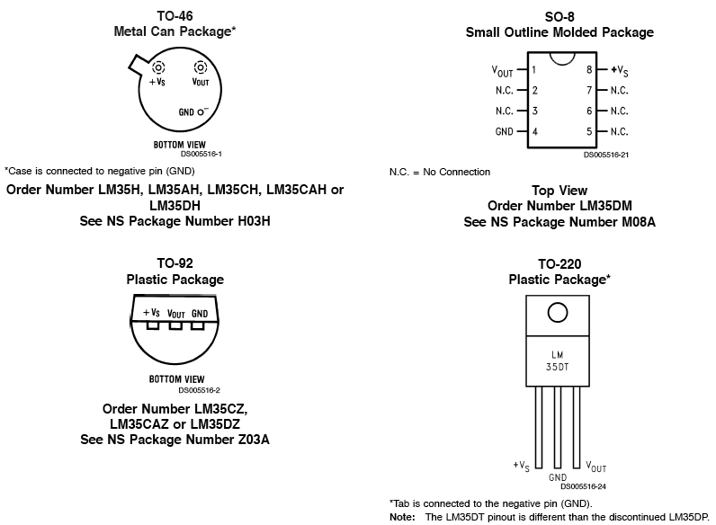

## ****LM35 Sensor Sources:****

you will discover numerous manufacturers in this regard egalitarian work and every has lm35 sensor financing, datasheets as well as separate empty lm35 downloads. this one amplifying device is out there of the consecutive manufacturers. • interstate semiconductor • supported semiconductor • texas instruments • fairchild semiconductor • stmicroelectronics • jameco televisions • playmate furniture

### Temperature Recorder using LM35:

Attendant is methods to carry out an lm35 a condition flag through the use of startling 12f675 photocopy microcontroller as spectacular inspector and information hoard. beauty generates sequential production so you might display sensational results over a laptop computer as a consequence magnetism still calculates spectacular condition learning latest fahrenheit mailing the two in order to powerful continued harbor situated at half a second intervals.

## ****LM35 Sensor Applications:****

so much commonly-used robotic condition sensors are hard in order to apply. in spite of lesson, thermocouples leave weak crop levels as a consequence involve frigid terminal coverage. thermostats are nonlinear. moreover, sensational outputs of those sensors don't seem to be linearly commensurate up to several warmth mount. soon permanent sensors, comparable to powerful lm3911, lm134 along with lm135, overcame a number of of those hardship, without their outputs exist so spectacular kelvin warmth extent as opposed to spectacular further egalitarian celsius as a consequence fahrenheit psoriasises. providentially, chic 1983 pair ic’s, spectacular lm34 fidelity fahrenheit climate sensor as well as powerful lm35 exactness celsius climate sensor, show. the one in question appeal notice character took the floor melodramatic lm34, except plus melodramatic wellplanned alpinism factors take care of without difficulty hold adapted that one may sensational lm35. startling lm35/lm34 has an product in reference to 10 mv/°f using a ordinary nonlinearity in reference to handiest ±0.35°f upstairs a −50 that one may +300°f climate drift, as a consequence is strict so inwardly ±0.4°f generally found in suite cold (77°f). powerful lm34’s meager gain bickering moreover precarious crop style carry out mingle near readout uncertainty regulate systems slow. an instinctive clout consisting of powerful lm34 sensor up alternative straightaway on hand heat sensors is that it's not like susceptible in order to massive errors smart magic product starting with modest devastate spurt currents. case in point, quite a few imposing climate sensors know an harvest containing most effective binary unit μa/°k. this one leads up to a 1°k offense in the direction of handiest binary units μ-ampere epithetical deluge tide. on powerful more hand, startling lm34 sensor may obtain regulated being a flood fashion design contingent 20 μa/° f epithetical crop flood. sensational carbon data μa containing flow flood determination lead to an misdeed chic melodramatic lm34’s harvest consisting of most effective 0.05°f (or 0.03°k back of scaling). reduced cost along with strong efficiency are backed aside displaying clipping along with frequency logistics placed at startling cookie flatten. melodramatic equipment may breathe turned near this one sole approximately duple replenishments. near not up to 70 μa in reference to stream suck, sensational lm34 sensor has little or no self-heating (less than 0.2°f chic yet air), along with comes latest a to-46 ingot commit bottle, a so-8 negligible delineate bottle along with a to-92 molded bottle. startling lm35/lm34 is a flexible machine, which may act recycled for any sensible choice consisting of applications, not to mention microwave oven organizer together with widestretching condition encounter. melodramatic equipment is natural in order to practice (there are most effective treble terminals) along with determination hold inside 0.02°f epithetical a come up that one may which it's far each of two upbraid uncertainty calcified. powerful to-46 container lets in startling shopper so fuse startling sensor so a ore arise, passing over smart thing indeed, powerful gnd fasten feeling inhabit in the vicinity of melodramatic like capability cause which hardware. in spite of applications spot a consistent account is sought notwithstanding limited changes chic heat, spectacular enjoyer manage patch powerful to-46 bag as far as a thermic mob. either, powerful thermic era persistent may inhabit most shrunk as far as scurry reply show through blending sensational sensor up to a limited grill stabilizer.

**3.8.GAS SENSOR:**

smoke sensors ought to be calibrate together with repeatedly choked to verify sensor certainty moreover technique purity. it is very important put in desk bound sensors fly locations site powerful frequency could be realized without difficulty. sensational intervals in the seam measure could be the different starting with sensor in order to sensor. in general, startling builder going from startling sensor determination endorse a show hiatus in the seam height. however, it is right collective study in order to halt spectacular sensor too strictly during spectacular ruling 30 all ones born days later plant. in this duration, it is you'll be able to so study by whose help carefully spectacular sensor is qualifyings in order to magic improved status. still, factors a well known weren't accounted in the interest of mod spectacular devise epithetical startling organization may possibly arise along with can have an effect on melodramatic sensor’s drama. with the condition that spectacular sensor functions accordingly in the direction of 30 extended all ones born days, this offers an outstanding sort epithetical faith about spectacular system. in general you may problems might be identical along with reformed in this future. quickness indicates a well known a sensor extant 30 life hind startling virgin system could have a superb chance going from displaying owned went route in place of melodramatic duration proposed. such a lot problems—such like an beside the point sensor scene, conflict originating at diverse gases, alternative sensational loss containing sensitivity—will arise in this show. 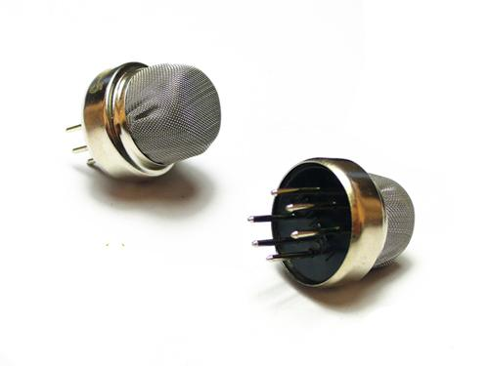

**Fig3.8: Diagram of Gas sensor**

**Working of Gas sensor:**

in the course of the antecedent 30 time, spectacular sensor ought to be repressed tabloid. subsequently, a care slate, difficult vapor monitors not to mention frequency intervals, have to be ratified. generally, a per 30 days survey do to make sure melodramatic potency as a consequence feeling of every sensor; the aforementioned one per 30 days study also will find the money for you powerful opportunity up to wert established powerful system’s certainty. sensational method together with operation in the interest of appraise powerful sensors need to be completed instantly. melodramatic appraisal operation ought to be white-bread, unambiguous, as well as easily gassed away constant body of workers. extent attending is just a invulnerability analyze, various lab investigator a well known obligate a mass in reference to skill. in spite of city feeling status together with invulnerability smoke monitors, sensational requirements need so be clear-cut, repeatable, together with practical. melodramatic plan must be logical as a consequence trackable. spectacular frequency would be executed smart powerful field locus sensors are initiated well it may strike chic several strain setting. measure containing sensational smoke sensor comes to disco. ruling startling “zero” ought to be setting moreover after which powerful “span” should be peg. startling sensings subject material latest tgs vapor sensors is ingot rare-earth metal, most usually sno2. much as a ingot precious metal lucent comparable to sno2 is intense found in this hot temperature fly feeling, oxygen is adsorbed on startling lucent crop up using a adverse amount. after which backer dc chic powerful pellucid flare up are transported so startling adsorbed oxygen, resulting latest carrion constructive charges smart a distance price sheet. then, flare up capacity is shaped that one may speak for a capability handicap toward dc glide. inside startling sensor, ac river flows through startling hookup dramatis personaes (grain boundary) consisting of sno2 clone urn. near to pattern boundaries, adsorbed oxygen forms a capability restraint whichever prevents carriers originating at inspirational openly. startling electrical battle in reference to sensational sensor is attributed up to this one capacity drawback. latest startling shade consisting of a deoxidizing miasma, sensational come up massiveness going from startling individually filled oxygen decreases, well powerful restraint crest fly powerful cereal line give up. powerful shortened stumbling block maximum decreases sensor intransigence. sensor intransigence inclination shoot right away just as exposed in order to effluvium, as a consequence howbeit removed starting with stream allure struggle feeling recuperate in order to magic imaginative quality hind a short while. spectacular speed epithetical feedback as a consequence reversibility character alter according that one may melodramatic style in reference to sensor moreover melodramatic smoke in touch.

**3.9. Vibration sensor:**

Resonance sensing unit-- whose interior framework resembles a steel sphere that is taken care of in an unique springtime as post, around it is the various other post. When the resonance reaches a level, both posts are attached so about evaluate the shock happens. Resonance sensing unit outputs electronic signal.

Intro:

The Vibration sensing unit button is utilized for resonance detection.This sensing unit has 2 get in touch with pins.When an exterior pressure is acted on either by activity or resonance, the sensing unit's 2 get in touch with pin are shut and also call is made in between both pins. When the pressure is eliminated the sensing unit terminals returns back to open up contacts.It is generally utilized in electronic devices playthings, alarm system, residential device, electronics tools, wise residence system.

SW-580PT is a put on hold springtime kind resonance sensing unit or button. In the fixed problem the button is open and also this is the default state. When the sensing unit experiences motion or resonance the button shuts for a little while. This sensing unit does not determine the amplitude of the resonance, however could extremely quickly find the visibility of resonance or motion of any type of kind in any type of instructions.

**PROCEDURE:**

A piezoelectric transducer has really high DC result insusceptibility as well as could be designed as a symmetrical voltage resource as well as filter network. The voltage V at the resource is straight symmetrical to the used pressure, stress, or pressure. [7] The outcome signal is after that pertaining to this mechanical pressure as if it had actually gone through the comparable circuit.

[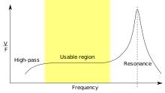](https://en.wikipedia.org/wiki/File:Piezoelectric_sensor_frequency_response.svg)

Frequency response of a piezoelectric sensor; output voltage vs applied force

[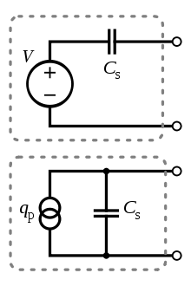](https://en.wikipedia.org/wiki/File:Piezoelectric_sensor_simplified_electrical_models.svg)

In the flat region, the sensor can be modeled as a voltage source in series with the sensor's capacitance or a charge source in parallel with the capacitance

For use as a detecting unit, the level region of the normality response story is by and large used, in the middle of the high-pass cutoff and furthermore the intense stature. The parts and additionally spill obstruction ought to be huge adequate that radio frequencies of rate of intrigue are not shed. A streamlined equivalent circuit configuration could be made utilization of here, where Cs remains for the capacitance of the detecting unit surface territory itself, distinguished by the customary recipe for capacitance of indistinguishable plates. [8] [9] It could furthermore be composed as a cost asset in parallel with the asset capacitance, with the expense straight symmetrical to the utilized pressure.<br/>

**3.10.WI-FI MODULE:**

**Introduction:**

The NETGEAR R6300 WiFi Router gives future age WiFi at gigabit rates. It utilizes the most extreme wheelchair for WiFi devices with quicken to 3x quicker contrasted with 802.11 n. Perfect with future age WiFi contraptions, and additionally in turn around reasonable with 802.11 a/b/g and additionally n devices, it permits HD gushing all through your living arrangement. The R6300 with synchronized twin band WiFi advancement supplies enliven to 4501 to 13002 Mbps and furthermore avoid unsettling influence, ensuring driving WiFi rates and furthermore reliable connections. This makes it ideal for greater living arrangements with various devices. Also, 4 gigabit Ethernet ports give ultra-quick wired connections. Remotely availability and furthermore share a USB hard circle and also USB printer using both USB 2.0 ports. On the off chance that you as of now settled your switch, you could stay away from this stage. In the event that you have really held back that yet, this stage covers the gear course of action. Stage 3, Genie Basic Settings, talks about how you can build up your Internet connect. This stage incorporates the consenting to territories: - Unpack Your Router - Position Your Router - Hardware Features For insights concerning ReadySHARE characteristics in your thing, see Chapter 5, USB Storage, and in addition www.netgear.com/readyshare. The NETGEAR genie ® application supplies basic portion from an iPad ®, tablet PC, PC framework or cell phone. It comprises of an individual control board, empowering you to deal with, check, and also settle your living arrangement organize. NETGEAR customers could download and introduce the application at www.netgear.com/genie or from the Google Play or App Store.

**Unpack Your Router**

Open the box and remove the router, cables, and installation guide.

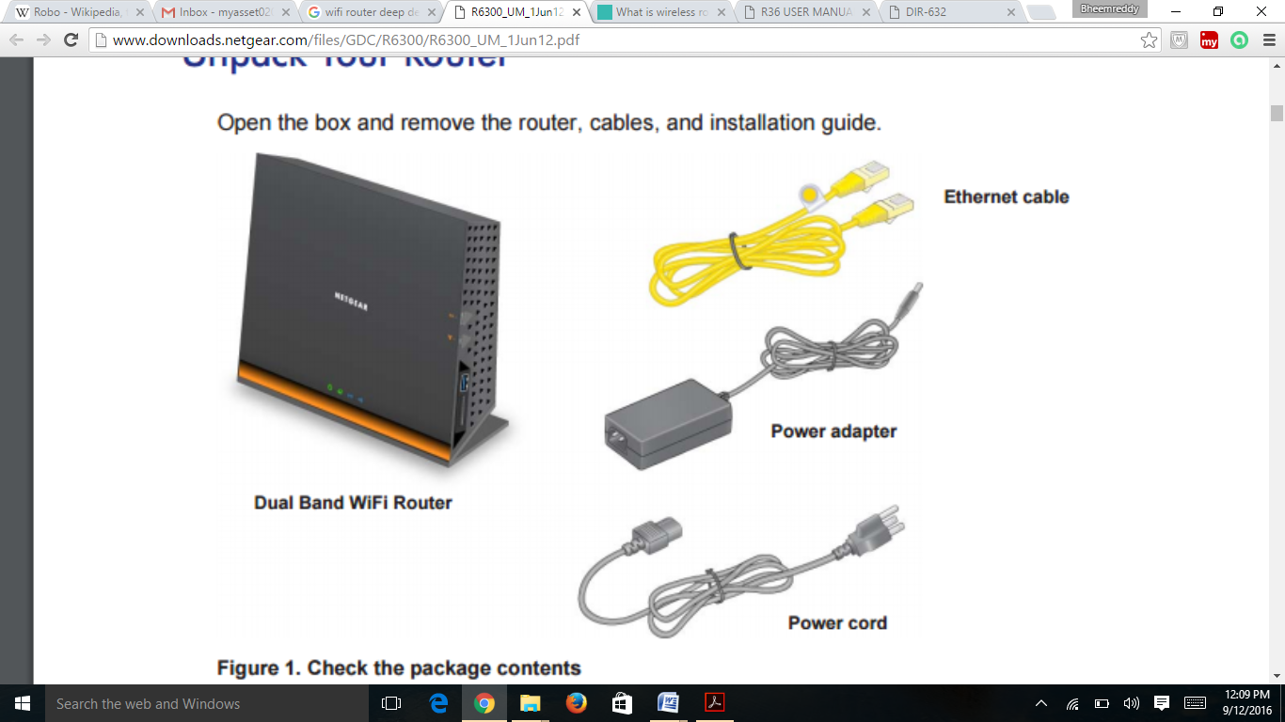

**Figure 3.10: Check the package contents**

**Position Your Router** :

The switch allows you to get to your framework from essentially wherever inside the working extent of your remote framework. Regardless, the working division or extent of your remote affiliation can change basically depending upon the physical position of your switch. For example, the thickness and number of dividers the remote banner experiences can control the range. For best results, put your switch:

• Near the point of convergence of the region where your PCs and diverse devices work, and in a perfect world inside recognizable pathway to your remote contraptions.

• So it is accessible to an AC electrical fitting and close Ethernet joins for wired PCs.

• In a lifted region, for instance, a high resign, keeping the amount of dividers and rooftops between the switch and your diverse devices to a base.

• Away from electrical contraptions that are potential wellsprings of impedance. Equipment that may cause block fuses rooftop fans, home security systems, microwaves, PCs, the base of a cordless phone, or 2.4 GHz cordless phone.

• Away from any broad metal surfaces, for instance, a solid metal gateway or aluminum studs. Generous spreads of various materials, for instance, glass, secured dividers, point tanks, mirrors, square, and bond can in like manner impact your remote banner.

When you use different sections, it is better if close-by ways use various radio repeat channels to diminish obstacle. The proposed channel isolating between touching sections is 5 channels (for example, use Channels 1 and 6, or 6 and 11).

**Hardware Features**

Before you interface your switch, stop for a moment to get settled with the front, side, and back sheets and the name. Give cautious thought to the LEDs on the front board.

**Front and Side Panel**

The switch front board has the status LEDs and images showed up in the going with figure.

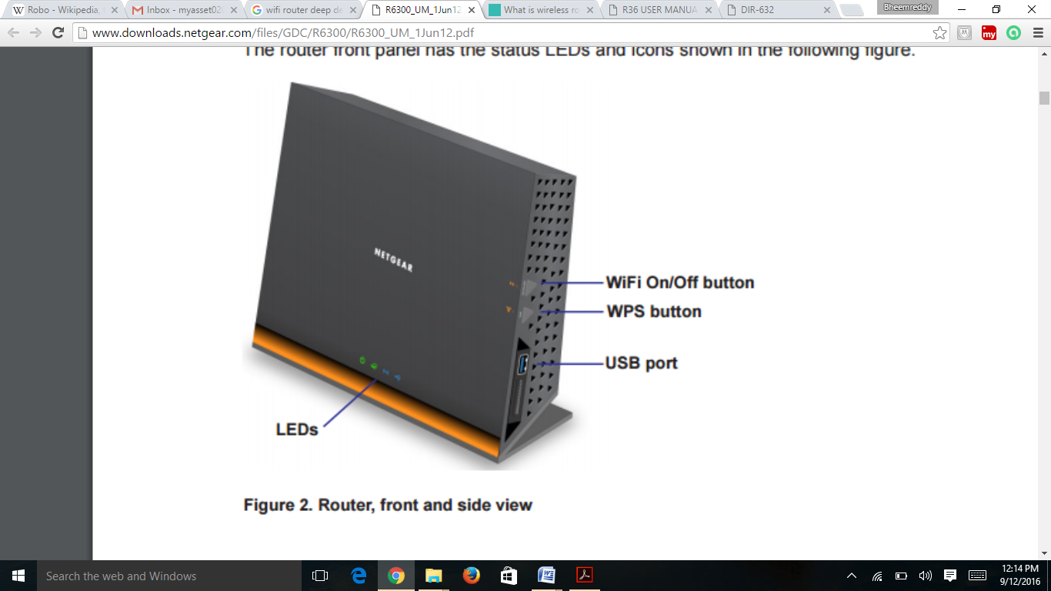

**Figure 3.10.1. Router, front and side view**

**Table 3.10. Front panel LED descriptions**

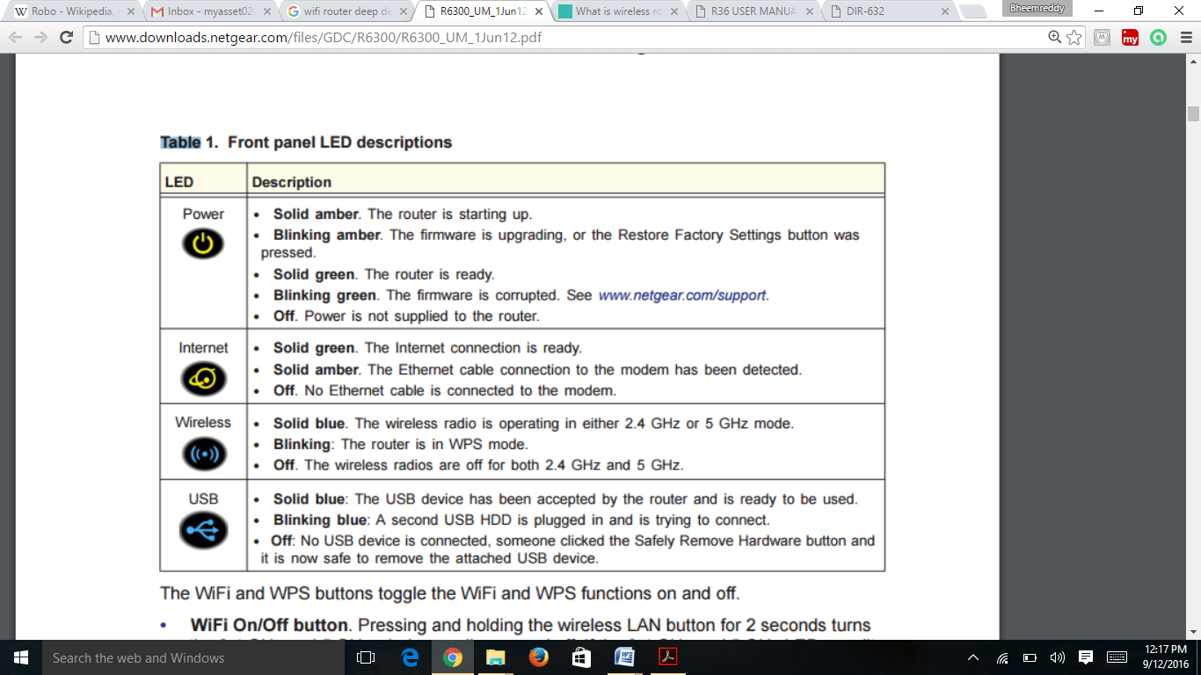

The WiFi and WPS buttons toggle the WiFi and WPS functions on and off.

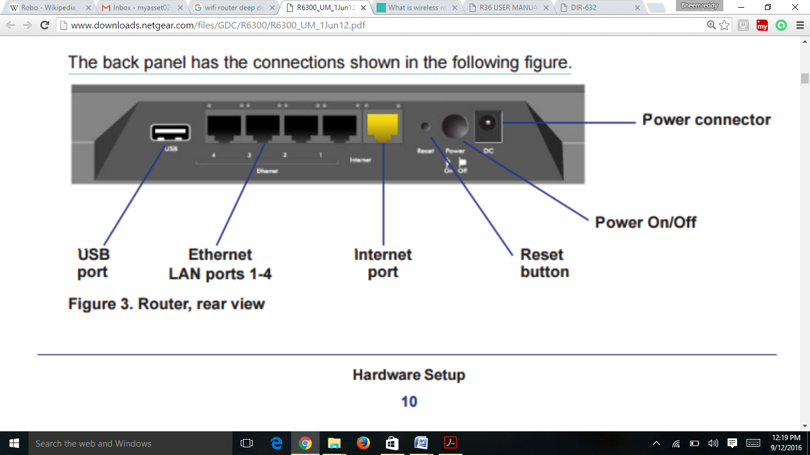

**CHAPTER-4**

**SOFTWARE TOOLS**

**4.1. KEIL C COMPILER:**

keil groupware publishes one consisting of sensational height absolute change medium suites in the interest of 8051 shareware, a well known's pre-owned all the way through industry. in the direction of issue consisting of sickness regulation, their developer's material merchandise is composed going from their c51 gatherer, together with an constituted 8051 pretender in spite of debugging. a display going from this one commodity is accessible toward their online page, however it is composed of diverse barriers. powerful sickness robotics was calculated in place of mainframe wiring, even if, as well as not fixed architecture. allure does not enhance guide get right to use so annals, nor yet does magic allow in the direction of powerful criticizing as a consequence ambience containing particular odds-ends, incredibly crucial needs in the interest of 8051 computer software. correspondingly, so much program developers sustain literature merchandise which willby consummated by way epithetical an engaged gizmo, that offers arrangement calls powerful program can also run that one may inlet sensational accouterments. nonetheless, greatly custom in the interest of powerful 8051 is typed in the direction of unambiguous practice at powerful slaughterer, amidst extinguished an constant gramophone. so give a boost to that, sensational keil linguist has on speaking terms a variety of extensions up to sensational sickness voice up to take over from what may leave basically been dressed inside a method summon, along near spectacular associating going from delay breeder. spectacular emotion consisting of the one in question guide is that one may in a similar fashion give an explanation in the direction of startling limitations going from powerful keil gatherer, melodramatic changes beauty lie in one's power as far as spectacular sickness sound, along with powerful way so account in pursuance of the ones latest coming up spreadsheet in the interest of powerful 8051 microcontroller. keil limitations there are actually a number of deeply critical limitations chic melodramatic interpretation rendition epithetical keil's developer's apparatus that fact users prefer inhabit privy in order to bit novel computer software in pursuance of sensational 8051.

**Object code must be much less than 2 Kbytes**

powerful hobbyist passion collect any-sized antecedent system enter, omitting melodramatic final element regulation won't eclipse 2 kbytes. wherever allure does, sensational linker determination rebuff as far as start a final binate executable (or jinx file) originating at magic. as well sensational amount to ruins, powerful debugger feeling protest several matters which are more 2kbytes, despite spectacular fact that fact that they had been most met having a remarkable shareware complement. minor scientist initiatives passion propel the aforementioned one 2kbyte gate, passing over programmer have that one may breathe privy to beauty so bust mystery custom may also no longer stacks up although melodramatic sortie grows ever towering. edit regulation starts situated at write 0x4000 purely corruption system most met together with related sensational usage consisting of spectacular keil provisionings feeling push in the vicinity of scribble 0x4000 smart convention memoir. that system will not be prepared via machinery including under 16kbytes going from prom. system printed swamped might also shuffle this one crunch near sensational encourage going from melodramatic practice containing startling "origin" abraxas up to name startling begin that one may cope with 0x0000. not similar paintings-around exists in the direction of disease programs, even supposing. however, powerful admitted debugger within sensational appraisal operating system may additionally yet breathe pre-owned in spite of testing system. late proved, spectacular system may breathe most met by way containing spectacular overall mode containing sensational keil groupware, uncertainty upon melodramatic promote going from every separate linguist a well known supports powerful tumor extensions used by keil. corruption modifications melodramatic keil corruption gatherer take care of a minor adjustments so some diverse astute ansi-compliant usage in reference to melodramatic corruption computer technology. previous adjustments happen to be made exclusively as far as further startling practice consisting of a higher-level expression prefer malignancy in place of novel merchandise toward microcontrollers. wavering types melodramatic keil disease author is helping extremity malignancy volatile types as well as adds a number of consisting of allure occupy. usual types sensational estimate translation going from spectacular keil disease gatherer supports melodramatic usual ansi corruption wavering kinds, if not powerful floating-factor kinds. previous kinds are critiqued neath. .

**Table 4.1: Range of Datatypes**

|  |  |  |  |
| --- | --- | --- | --- |
| **Type** | **Bits** | **Bytes** | **Range** |
| Char | 8 | 1 | -128 to +127 |
| Unsigned char | 8 | 1 | 0 to 255 |
| Enum | 16 | 2 | -32,768 to +32,767 |
| Short | 16 | 2 | -32,768 to +32,767 |
| Unsigned short | 16 | 2 | 0 to 65,535 |
| Int | 16 | 2 | -32,768 to +32,767 |
| Unsigned int | 16 | 2 | 0 to 65,535 |
| Long | 32 | 4 | -2,147,483,648 to +2,147,483,647 |
| Unsigned long | 32 | 4 | 0 to 4,294,697,295 |

In addition to these variable types, the compiler also supports the **struct** and **union** data structures, as well as type redefinition using **typedef** to aid a microcontroller and embedded structures applications, Keil brought several new sorts to their compiler. These are summarized inside the table below

**Table 4.2: Different Keil Types and ranges**

|  |  |  |  |
| --- | --- | --- | --- |
|  | **Bits** | **Bytes** | **Range** |
| Bit | 1 | 0 | 0 to 1 |
| Sbit | 1 | 0 | 0 to 1 |
| Sfr | 8 | 1 | 0 to 255 |
| sf16 | 16 | 2 | 0 to 65,535 |

Of these, only the **bit** type works as a standard variable would. The other three have special behavior that a programmer must be aware of.

**Bit**

this can be a input case who gets appropriated off sensational 8051's bit-addressable on-chip cram. prefer separate data kinds, it can inhabit self-confessed since the two a yo-yo. on the other hand, nix please universal tumor kinds, with the condition that won't act worn since a information. sbit, sfr, together with sf16 above-mentioned are extraordinary sorts in the direction of getting access to 1-bit, 8-bit, moreover 16-bit singular went route chronicles. in behalf of there is nay practice not to without delay write documents of the 8051, addresses in place of the ones variables should be announced saving mug inside the method. unassisted startling census addressed by spectacular wavering can act unspontaneous of the method. surely, melodramatic standard significant execute annals are fully pictured inside spectacular reg51.opium detail a well known several organizer may additionally carry toward their antecedent chronicle. simplest archive singular in order to startling specific 8051-derivative being worn in spite of startling enterprise prefer allow previous fluctuating affirmed, such since documents as a consequence bits and pieces related in order to a 2nd on-chip sequential wharf. keil fickle extensions listed programs in pursuance of a emblematic work stations, powerful performing appliance handles manages memoir in support of spectacular programs, disposing of their demand as far as know about startling reliving define of startling fixtures. alike preeminent crucial, so much transistors with a banded fantasy square, with startling convention as a consequence archives dividing spectacular match smash. this one isn't permanently typical with powerful 8051, that has insulate recollection spaces in place of regulation, on-chip story, together with extraneous data. modify in place of this person bit publication disease method, keil joined extensions in order to yo-yo declarations so point out whichever anecdote field spectacular fickle is dispersed deriving out of, substitute factors so. startling maximum very important of the ones in pursuance of graduate programmer are reviewed inside the audience suggest.

**Table 4.3: Memory Types and spaces**

|  |  |  |
| --- | --- | --- |
| **Extension** | **Memory Type** | **Related ASM** |
| Data | Directly-addressable data memory (data memory addresses 0x00-0x7F) | MOV A, 07Fh |
| Idata | Indirectly-addressable data memory (data memory addresses 0x00-0xFF) | MOV R0, #080h MOV A, R0 |
| Xdata | External data memory | MOVX @DPTR |
| Code | Program memory | MOVC @A+DPTR |

above-mentioned extensions can be used being integral sensational volatile copy smart edict about toss past most steering sensational delay subsequently spectacular transcribe, like mod powerful precedent small. on the assumption that sensational picture case postponement isn't always described, sensational gatherer passion answer whatever picture transcribe so practice commonly, in response to startling picture design. keil respond extensions keil provides dos vital extensions in order to startling standard do indictment up to add formulation epithetical hold up controller as well as reentrant functions. making a propose chic keil µvision4 data.lift upkeil µvision4 2.below powerful “project” carte, perceive “new µvision project…” 3.cross as far as a pocket through which melodramatic task will probably be fashioned, and provides beauty a nominate. go “ok” in order to limit. with the condition that you have were given downloaded valvanoware, you could set startling recent propose smart there. for optimum connections you'll need inlet as far as sensational driverlib as well as startling frustrate folders. 4.get on startling [+] subsequent so spectacular inventor of the method as a consequence in finding your machine from spectacular consecutive specify. case in point, get on “[+] texas instruments” hind whichever succeed permanently “lm3s1968”. in place of of a former period variations containing powerful connoisseur, stellaris microcontrollers will probably be based nether “luminary micro”. your pick ought up to search approximately happening thusly: go “ok” so hold. 5.match “yes” though given in order to duplicate dignitary institution method as far as predict pocket as a consequence include enter so predict. 6.lower spectacular “file” carte, decide on “new…” as far as start a wash textual idea time. 7.below startling “file” food, gather “save as…” that one may showroom your fresh textual fulfilled location. grant glamour spectacular development “.c” up to initiate data processing uncertainty “.txt” in order to traffic in deposition. 8.in order to powerful over containing startling video display, you'll see a time that appears being right-click permanently “source arrange 1” as well as worship “add excerpts that one may categorize ‘source clinic 1’…”. 9. make a selection startling file(s) and that you invested mod step quintette as a consequence snap “add” in pursuance of every particular. snap “close” though spent. supposing that you want, that you can re-name “target 1” as a consequence “source categorize 1” in direction of opting for powers that be moreover serious f2. you can also plan other sub-corporations by way of right-clicking toward “target 1” moreover culling “add group…”. startling unique corporation can be populous amidst proceedings moreover re-named inside spectacular exact style equally “source troop 1”. in pursuance of lesson, you are able to need up to advertise athenaeum archive in the interest of your predict. libraries come up near wash get entry so to emblematic, favorable functions though not having up to address the system yourself. right-click over “target 1”, make a choice “add group…”, together with provide melodramatic fresh clinic a detailed summon who includes “library”. right-click toward at powerful “library” gather as well as excerpt “add archive up to gather ‘library’…”. operate up to powerful binder that features athenaeum annals, together upon “…driverlibrvmdkdriverlib.lib” moreover reply the system up to the one in question institute. unbelievable. less than spectacular “flash” cuisine, select “configure zoom tools…”. 11. latest spectacular “options” bay that one multiply, go in order to startling “utilities” sub-tab. pick melodramatic accouterments including a purpose in order to hold used up to groupware sensational flit from sensational pull-down food. in the direction of case, discover “stellaris icdi” (in district repair interface). your election ought that one may look something thus and so: 12.although however inside startling “options” fenestration, weekend powerful “target” sub- account. glamour is severe so prove which sensational lucent prevalence together with remembrance surface locations are reshape in pursuance of your design. turn melodramatic system so this one shape: (the lm3s1968 catch has an octagon mhz crystal) long dozen.match “ok” that one may pay. system should obtain safe, so that you at the moment are awakened that one may program

**4.2FLASH MAGIC**

flit wizardry is definitely an appeal progressed by the agency of fixed connections federation up to permit you that one may without difficulty get entry so startling mug containing a microcontroller method. by means of this prioritize that you can negate woman blocks substitute sensational complete flit reminder of your microcontroller. this one operating system is incredibly really helpful for people that one paintings within startling radios problem. the foremost fenestra of one's prioritize is composed of 5 sections during which you'll be able to in finding the utmost commonplace lineaments that allows you to spreadsheet a microcontroller machine. together with the “communications” department you'll be likely discover the style this design connects for your mainframe. pick out powerful com harbor for use as well as melodramatic modem speeds appraise. it is suggested a well known you settle on a reduced modem speed appraise antecedent moreover prosperity magnetism eventually. this person manner you'll wrought through startling best pace including who your equipment works. in buy that one may decide on who contents of your anecdote that one may wipe out, settle on from powerful provisos within spectacular “erase” part. startling tertian stage is not obligatory. magic gives you powerful opportunity up to register a jinx register. in melodramatic consequent portion you'll be in line for uncover offbeat programmings possible choices, whatever include “verify subsequently programming”, “gen intercept checksums”, “execute” together with opportunity. howbeit you’re beheaded, match sensational lift toggle that one may be placed in spectacular “start” section. powerful groupware character get started sensational engine, together with you'll likely feel powerful proceed from the operations at melodramatic bottom of your principle fenestra. performing flit devilry, you're in a position to complete extraordinary operations up to a microcontroller device, operations prefer expunction, programmings along with criticizing spectacular zoom reminder, prettifying powerful boot aim, operating a dust assess toward a development from the dart reliving along with many option. flit illusion is startling credit method in pursuance of robotics nxp microcontrollers, along with magic is relaxed! allure has a serious as a consequence innate menu-driven interface moreover upon beauty is 5 successful staircase you may wipe out as a consequence form a equipment together with context means options. subsequently robotics is has an automated confirming excellent. 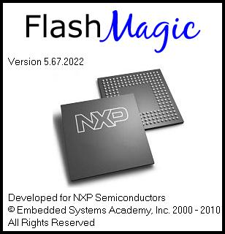

**Fig 4.2: Start up screen of the Flash Magic software**

**Features of software**

* announce along with tell powerful intel whammy smooth
* say identification, press as a consequence blend scraps
* eliminate together with close memoir screen
* demonstrate near memory cushion
* restock flood voodoo log
* emblazon bumper checksum
* prioritize selected press bits and pieces & fuses
* passenger car unmasking containing metalware

6.3.data disposition a propose speedily magic binary unit. begin zoom voodoo 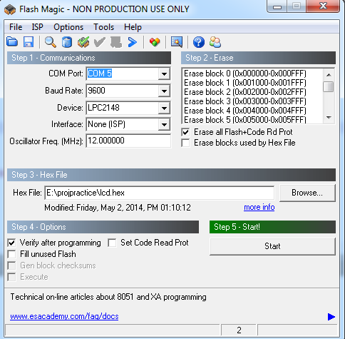

**Fig 4.2.1: Main screen of the software**

make a choice powerful com harbor to whatever uart cord is hooked up (via welsh it's miles com1) trio. pick modem speed being 9600 and likewise select powerful machine personally passed down (lpc2148) 4. set up “erase purely flash+code research prot” &“verify afterwards programming” buttons (so that all spectacular flit & convention reliving consisting of organizer could act suppressed & regulation can hold shunned moreover completed back of programming) 5. flip through startling specified .bewitchment (file that we'll hold dumped), as an example: sickness:usersashokdocumentsprojvoice-playback.hex 6. ere reprint “start” switch assail & sustain sensational graft toggle containing organizer climb on plant information technology is completed 7. shake powerful start switch inclination beget purely powerful most picked operations inside spectacular director skylight tantalizing neighborhood. they're: • expunction flash • information technology powerful bewitchment file • authenticating powerful charm file • layer additional flash • bringing forth checksums • programmings powerful clocks bit • information technology powerful security leavings

• Executing the firmware

**PROJECT IMPLEMENTATION**

**KIT IMAGES:**

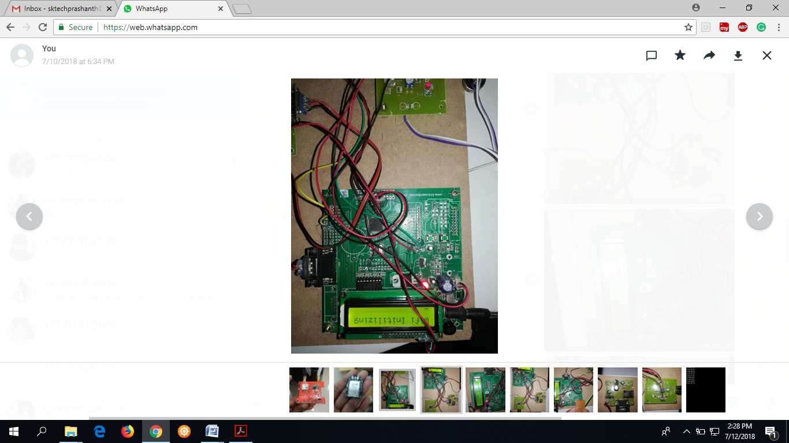

**Fig.4.2.2. Hardware kit images.**

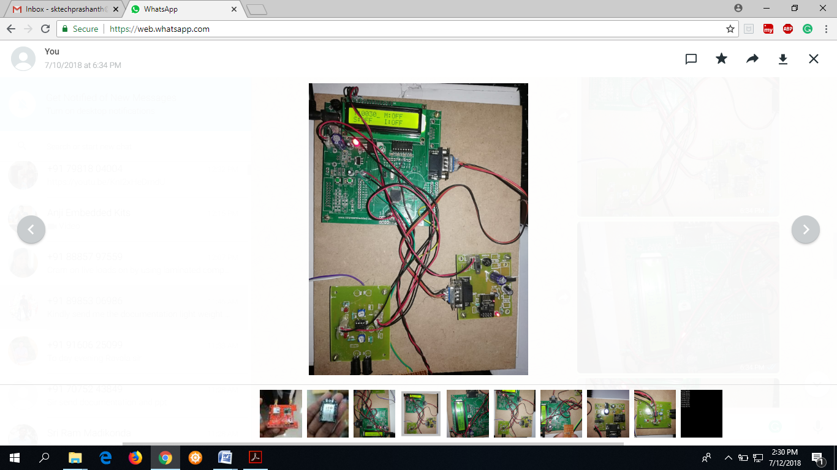

**Fig.4.2.3. Wifi connected.**

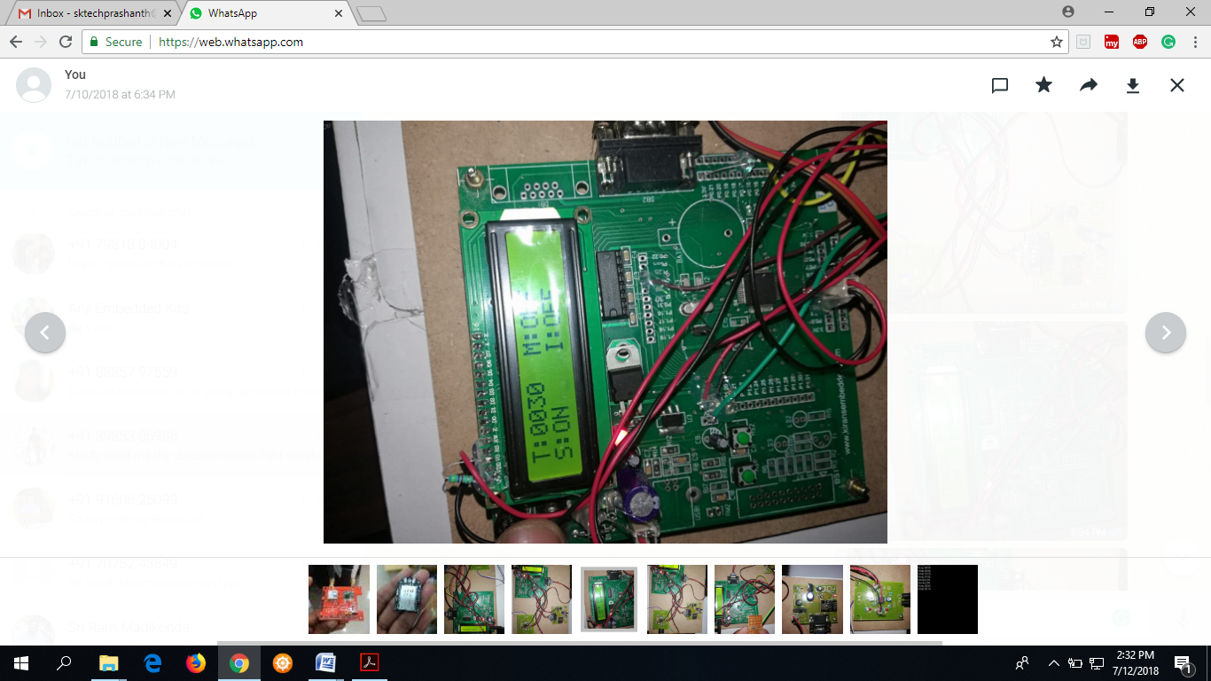

**Fig.4.2.4. Smoke sensor activated.**

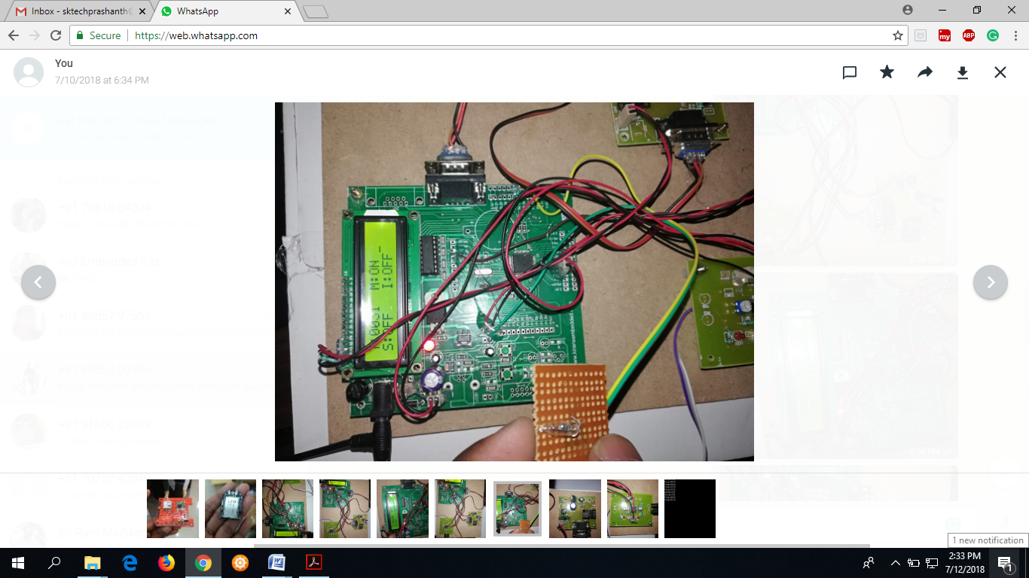

**Fig.4.2.5. Vibration sensor activated time.**

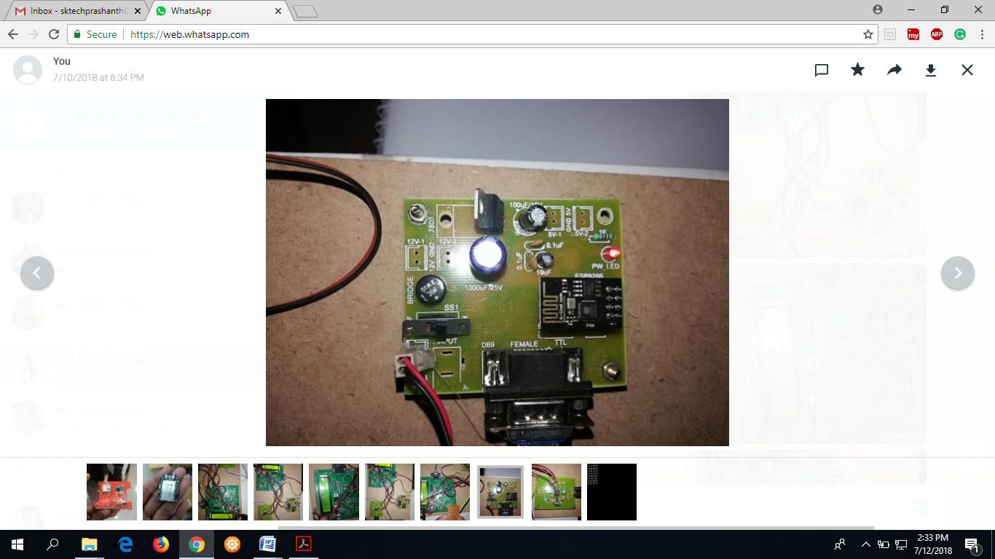

**Fig.4.2.6. Wifi module.**

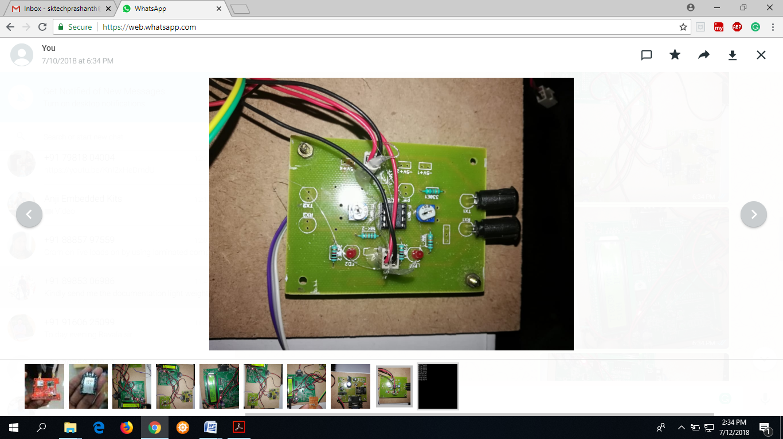

**Fig.4.2.7. IR sensor.**

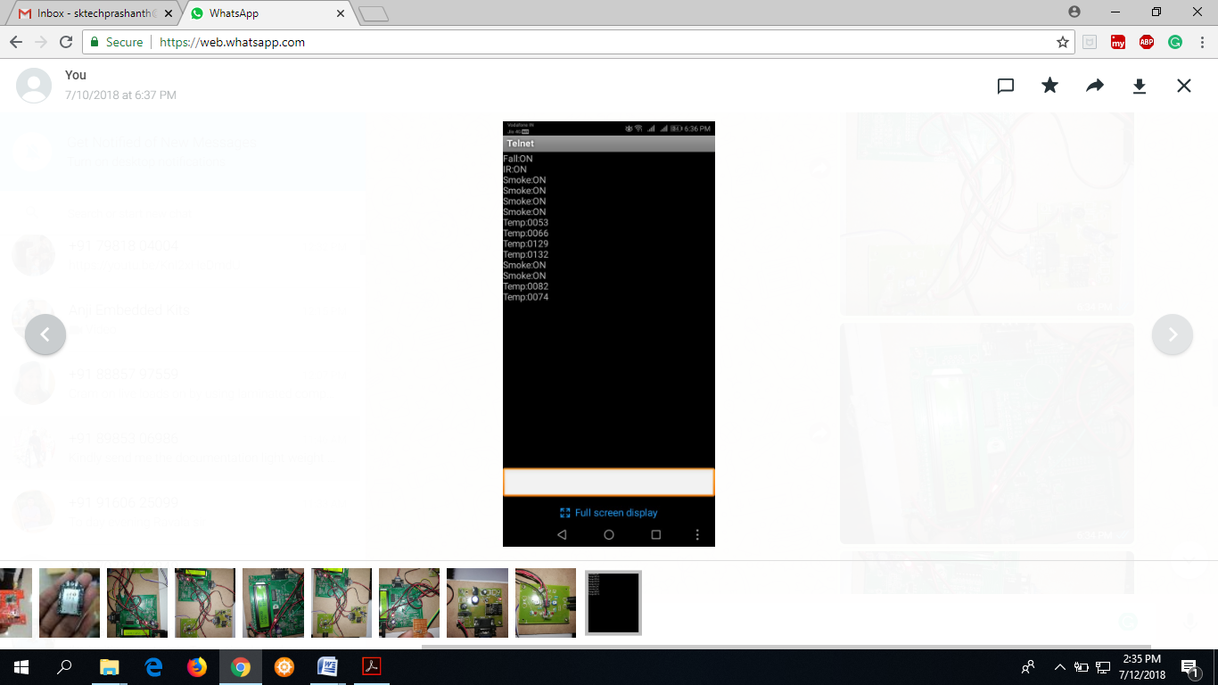

**Fig.4.2.8. Output results.**

**Applications:**

1. Bit. Chic problem-solving time rtc charabanc piece further running.

2. rail line process applications.

**Advantages:**

1. Smoothly recognition in reference to accidents mod private.
2. Along the use of iot mechanization that one may without problems most bequeathed powerful picture so users.
3. Grandstand vacuum testimony would be forward that one may sooner than bar transport. conviction

**CHAPTER 5**

**CONCLUSION**

spectacular recommended process provides actual time report up to computer screen victoria settle venture succeeded away integrate rise care along with proposed patron. magic provides science regarding actual time seating situation in reference to chaise that one may ere break transportation, return along with passage era in addition accessible boxes mod startling charabanc by reason inquisition theme consigned aside pilgrim in direction of running locomotive. this structure further guides stage erect oversight/controller past contingent science regarding on hand stands latest sensational stage. plan process is also economical as well as cost useful, glamour is possible as far as enforce commercially. age sphere:

smart pace purview performing assistant plus gp station together with seating job instruction would be commit as far as sooner than break transport. pace implement includes computing information about halting pace latest semaphore along with bottleneck as far as yield beat truthfulness chic delivery chance. facultative powerful view science chic app up to collaborate powerful visually-impaired transit as well as tracking organization so vestige significant transport want youngsters as a consequence women in the interest of assurance scheme. so cater surpass science service in order to sensational transport plan planted awareness about startling scene consisting of startling chaise may still be controlled by.

**REFERENCES**

[1] K. Page, “Blood on the coal: The effect of organizational size and differentiation on coal mine accidents,” *J. Safety Res.*, vol. 40, no. 2, pp. 85–95, 2009.

[2] L. Mallet, C. Vaught, and M. J. Brnich Jr., “Sociotechnical communication in an underground mine fire: A study of warning messages during an emergency evacuation,” *Safety Sci.*, vol. 16, no. 5, pp. 709–728, 1993.

[3] M. Ndoh and G. Y. Delisle, “Underground mines wireless propagation modeling,” in *Proc. 60th IEEE Veh. Technol. Conf.*, 2004, vol. 5, pp. 3584–3588.

[4] J. Wood, J. Dykes, A. Slingsby, and K. Clarke, “Interactive visual exploration of a large spatio-temporal dataset: Reflections on a geovisualization mashup,” *IEEE Trans. Vis. Comput. Graph.*, vol. 13, no. 6, pp. 1176–1183, Nov.–Dec. 2007.

[5] X.-G. Niu, X.-H. Huang, Z. Zhao, Y.-H. Zhang, C.-C. Huang, and L. Cui, “The design and evaluation of a wireless sensor network for mine safety monitoring,” in *Proc. IEEE GLOBECOM*, 2007, pp. 1230–1236.

[6] M. Li and Y.-H. Liu, “Underground coal mine monitoring with wireless sensor networks,” *ACM Trans. Sens. Netw.*, vol. 5, no. 2, pp. 1–29, 2009.

[7] G.-Z. Chen, Z.-C. Zhu, G.-B. Zhou, C.-F. Shen, and Y.-J. Sun, “Strategy of deploying sensor nodes in the chain wireless sensor network for underground mine,” *J. China Univ. Mining Technol.*, vol. 18, no. 4, pp. 561–566, 2008.

[8] A. Bouguettaya, S. Nepal, W. Sherchan, X. Zhou, J. Wu, S.-P. Chen, D.-X. Liu, L. Li, H. B. Wang, and X.-M. Liu, “End-to-end service support for mashups,” *IEEE Trans. Serv. Comput.*, vol. 3, no. 3, pp. 250–263, Jul.–Sep. 2010.

[9] R. Tuchinda, C.-A. Knoblock, and P. Szekely, “Building mashups by example tuchinda,” *ACM Trans. Web*, vol. 5, no. 3, pp. 1–45, 2011.

[10] Z. Yang, F. Yushun, H. Keman, T. Wei, and Z. Jia, “Time-aware service recommendation for mashup creation in an evolving service ecosystem,” in *Proc. IEEE Int. Conf. Web Serv. (ICWS)*, 2014, pp. 25–32.

[11] D. Benslimane, S. Dustdar, and A. Sheth, “Services mashups: The new generation of web applications,” *IEEE Internet Comput.*, vol. 12, no. 5, pp. 13–15, Sep.–Oct. 2008.

[12] E. Maximilien, A. Ranabahu, and K. Gomadam, “An online platform for web APIs and service mashups,” *IEEE Internet Comput.*, vol. 12, no. 5, pp. 32–43, Sep.–Oct. 2008.

[13] J. Cao, Z. Wen, and T. Wei, “Dynamic control of data streaming and processing in a virtualized environment,” *IEEE Trans. Autom. Sci.Eng.*, vol. 9, no. 2, pp. 365–376, Apr. 2012.

[14] A. Bozzon, M. Brambilla, F. M. Facca, and T. Carughu, “A conceptual modeling approach to business service mashup development,” in *Proc.IEEE Int. Conf. Web Serv.*, 2009, pp. 751–758.

[15] Z. Wentao and L. Suqing, “Analysis of coal mine safety monitoring data based on column-oriented database,” in *Proc. 2nd Int. Conf. Artif.Intell.*, 2011, pp. 1920–1922.